1

Summer Math Reinforcement Packet
Students Entering into 4th Grade

Our third graders had a busy year learning new math skills. Mastery of all these skills is extremely important in order to develop a solid math foundation. The fourth grade math program will add onto these third grade skills, so any time spent learning or reinforcing these concepts will be very beneficial for your child. Each year builds upon the previous year’s skills in math. Any areas your child has difficulty, you may want to give them additional practice. Student mastery of the basic math skills is as important to success in future mathematical procedures and reasoning as learning the alphabet is to reading and writing.

Have your child complete one page (one side), three times a week of the math packet. Please return this completed packet to your fourth grade teacher when school starts.

After your child has completed the math problems and you feel your child is still struggling on a certain concept and needs further practice, you can visit some of the web sites listed on the next page. You can also make up problems of your own for additional practice.

Also included is an answer key on different color paper for parents use only in assisting your child.

Reminder - Practicing multiplication (up to 12) and division facts are VERY important!

Enjoy your summer!!

2

THIRD GRADE

GRADE LEVEL EXPECTATIONS IN MATHMATICS

When entering fourth grade this is what is expected that your child should already know.

- Read, write and order numbers to 10,000 in both numerals and words.
- Identify the place value of a digit in a number. Example: 3,241, the 2 is in the hundreds place.

- Recognize and use expanded notation for numbers to 9,999. Example: 2,517 is 2,000 + 500 + 10 + 7; and 4 hundreds and 2 ones is 402.

- Can count orally by 6’s to 72, 7’s to 84, 8’s to 96 and 9’s to 108. Fr om previous years they should already know how to count by 2’s, 3’s, 4’s, 5’s and 10’s.

- Know even numbers end in 0, 2, 4, 6, or 8 and odd numbers end in 1, 3, 5, 7, or 9.
- Add and subtract fluently two numbers with regrouping through 999.

- Can estimate the sum or difference of two numbers with 3 digits (rounding the numbers then adding or subtracting them).

- Know multiplication facts through 10 x 10 fluently.

- Understand multiplication and division fact families and the inverse relationship of these two operations (just like addition and subtraction). Example: 3 x 8 = 24, the 24 ÷ 8 = 3 and 24 ÷ 3 = 8.

- Can solve 7 x ___ = 42 or 12 ÷ ____ = 4 using the above inverse relat ionship between multiplication and division as stated in #9. Example: 7 x ____ = 42 think 42 ÷ 7 = 6 so 7 x 6 = 42.

- Mentally calculate a product up to a three-digit number (even hundreds) by a one digit number. Example: 500 x 3 (5 x 3 = 15 then add 2 zeros at the end for 1500) or

70 x 4 (7 x 4 = 28 then add a zero for 280).

- Understand basic fractions and the terms numerator and denominator.
- Recognize, name and use equivalent fractions with denominators 2, 4 and 8. Can use fraction strips.

- Recognize that addition and subtraction of fractions with same denominators. Example ¾ = ¼ + ¼ + ¼ .

- When dealing with money, can relate fractions, decimals with dollars. Example: ½ dollar = $0.50, fifty cents and; ¼ dollar = $0.25, one quarter, 25 cents.

- Add and subtract money in dollars and cents.

- Use common units of measurements in length, weight, and time. Example: 12 inches = 1 foot;
3 feet = 1 yard; 16 ounces = 1 pound; 60 minutes = 1 hour; 24 hours = 1 day; 12 months = 1 year.

- Know benchmark temperatures such as freezing (32˚F , 0˚C); boiling (212˚F, 100˚C).

- Know that meters and centimeters are measurement like feet and inches; kilograms and grams are weight like pounds; liters and milliliters are like ounces (capacity of liquid).

- Can calculate the perimeter of a square or rectangle. Perimeter is the outer edge; you add the lengths of the 4 sides.

- Understand that area of a square or rectangle is the space in the middle (length x width).

- Identify perpendicular and parallel lines. Perpendicular- two lines that form a right angle.
Parallel- two lines that will never cross they go along side one another.

- Identify two-dimensional shapes: parallelogram, trapezoid, circle, rectangle, square, and rhombus.

- Identify three-dimensional solids: cube, rectangular prism, sphere, pyramid, and cone. Faces are the flat surface, edges are the straight folds where 2 faces come together, vertices is the point where 3 or more edges come together.

- Read and interpret bar graphs
- Knows maximum, minimum and range of a set of values. Range is the largest subtract the smallest.

3

Excellent websites for fun learning and reinforcement of math skills:

www.wildmath.com Select “Play the game”. Select addition, subtraction or multiplication and grade. You can race to beat your time.

www.harcourtschool.com Click the red box, select math, select HSPMath, select Michigan, click on the “3” ball or “4” ball for a challenge. Select a game.

www.aplusmath.com Go under “Flashcards” or “Game Room” on the left side of the screen. They can practice adding, subtracting and multiplying. Very important to know the addition, subtraction and multiplication facts from memorization or within a couple seconds.

www.mathisfun.com Select numbers then Math Trainer for adding, subtracting and multiplication. Or at the home screen select games and pick a game to play.

www.eduplace.com Select your state – “Michigan” press submit. Select the student tab then click on the “mathematics” rectangle. Click in the center book “Houghton Mifflin Math 2007”, Click on “Grade 3. Select any games. Extra Help and Extra Practice is good, also eGames.

www.illuminations.nctm.org Select activities then select grade level. Click on Search.

www.aaamath.com At the top pick “Third” or “Fourth” for a challenge. Choose any of the activities like multiplication then select “play” option toward the top of the screen. 20 Questions and Countdown games are good ones.

www.funbrain.com Lots of fun games to choose from.

Other games and activities you can play:

- Take a deck of cards and remove the face cards (kings, queens, jacks). Aces are one. Divide the cards evenly among 2 players. Each player flips over a card. The first one to add the 2 numbers correctly wins the cards. After going through the pile of cards, the player with the most cards wins. You can do a multiplication version also.

4

TERMS

Sum: the answer to an addition problem.
Difference: the answer to a subtraction problem.

Product: answer to a multiplication problem.
Quotient: answer to a division problem.

Edges: This is all the straight lines of a figure. Like the edge of a desk, where 2 faces come together. Faces: This is the flat surface of a figure.

Vertex: This is all the corners of a figure. The point where 3 or more edges come together.

Perimeter: You add up all the sides. (You are adding all lengths of the outer edges together.)

Area: Area of a square or rectangle = length (l) x width (w) answer is written in “square inches” (or whatever the measurement is)
Area of a parallelogram is length x height.
Answer written in “square inches” (or wh atever measurement) height

length

Median: Arrange numbers from smallest to largest. What number is in the middle? That is the Median number.

Mode: What number occurs most often? This number is the mode.

Range: Subtract the largest number in the group from the smallest number in the group. This number is the range.
Maximum: Largest number in the set of numbers. Minimum: Smallest number in the set of numbers.

Conversion:

60 seconds = 1 minute
60 minutes = 1 hour

24 hours = 1 day
12 months = 1 year

12 inches = 1 foot

3 feet = 1 yard

10 millimeter = 1 centimeter (approx. 3 ½ centimeters= 1 inch) 100 centimeter = 1 meter (approx. 1 meter = 1 yard)

5

Entering 4th Grade Summer Math Packet

First Name: ___________________________ Last Name:____________________________________

4th Grade Teacher: _____________________

I have checked the work completed:__________________________________________________

Parent Signature

DO NOT use a calculator when completing this packet.

1. Write the products: Practice any you do not know quickly.

4 | 8 | 11 | 2 | 2 | 7 | 10 | 12 | 6 | 5 | 9 | 5 | 0
x2 | x4 | x2 | x5 | x3 | x5 | x3 | x4 | x3 | x4 | x4 | x3 | x2

3 | 9 | 2 | 5 | 7 | 10 | 6 | 5 | 11 | 1 | 4 | 8 | 11
x3 | x5 | x7 | x5 | x4 | x4 | x4 | x2 | x5 | x3 | x5 | x2 | x4

6 | 8 | 6 | 3 | 9 | 10 | 12 | 3 | 7 | 4 | 9 | 4 | 12
x5 | x4 | x2 | x4 | x3 | x2 | x3 | x5 | x3 | x4 | x2 | x3 | x2

- Mrs. Count was born in the year one thousand, nine hundred forty-two. In what year was she born?
  - 1429

  - 1492
  - 1924

  - 1942

3. Which correctly completes the number sentences? 53,277 <__________

  - 49,999
  - 50,400

  - 52,388
  - 61,003

- Which number is fifty-two thousand, three hundred nine?

  - 5,239
  - 52,039

  - 52,309
  - 52,390

- What is the digit in the ten-thousands place of the number 68,173?

  - 1
  - 6

  - 8

6

- What is the place value of the 8 in the number 5,280?

  - ones
  - tens

  - hundreds
  - thousands

- Which number is equal to 5,912?

  - 5 hundreds, 9 tens, and 12 ones
  - 5 thousands, 91 hundreds, and 12 ones

  - 5 thousands, 9 hundreds, and 12 ones
  - 5 thousands, 9 hundreds, 1 ten, and 2 ones

- The number 9,036 is equal to which of the following?

  - 900 + 30 + 6
  - 90 + 30 + 6

  - 9000 + 30 + 6

- Which number means 7 thousands, 4 tens and 5 ones?
  - 745

  - 7,045
  - 7,450

- Which number goes in the blank to make the statement below true?

5,642 < _____ < 6,633
  - 6,931

  - 5,610
  - 6,745

  - 5,841

- When counting by 6’s, which of the following patterns is correct?
  - 0, 6, 12, 16, 22, 28, 34

  - 0, 6, 12, 18, 25, 31, 37
  - 0, 6, 12, 18, 24, 30, 36

- What number comes next in this pattern 41, 43, 45, 47, _____?

  - 48
  - 49

  - 50

- Which number can be shared in two equal groups with no remainder?
  - 85

  - 490
  - 223

- Martina has a new box of 64 crayons. She drops the box and 17 crayons are broken. How many crayons are NOT broken?

  - 47 crayons

  - 57 crayons
  - 53 crayons

  - 81 crayons

7

- How much is 2,470 + 1,423? Show your work.

  - 1,053
  - 3,763

  - 3,893

Remember “bottom bigger better borrow” when subtracting. Do you need to borrow from the tens?
16a. 82 subtract 65 = |  |  | 16b. | 61 subtract 18 =
A. 17 |  |  |  | A. 52
B. | 23 |  |  | B. | 57
C. | 27 |  |  | C. | 43
D. 13 |  |  |  | D. 47
17a. 80 subtract 34 = |  |  | 17b. | 85 subtract 64 =
A. 54 |  |  |  | A. 19
B. | 46 |  |  | B. | 21
C. | 56 |  |  | C. | 11
18. How much are 8,965 subtracting 3,525? Show your work.
A. | 5,440 | C. | 6,440
B. | 5,480 | D. | 12,490

- The lunchroom serves only hamburgers and pizza on Mondays. Last Monday, 314 students bought a lunch. There were 97 students who bought hamburgers. Which of the following is closest to the number of students who bought pizza?

  - 100 students
  - 200 students

  - 300 students
  - 400 students

- The best estimate of the sum of 389 and 403 is:

A. 600 | B. 700
C. 800 | D. 900

- Which division statement is related to 6 x 4?

  - 24 divided by 4
  - 64 divided by 4

  - 10 divided by 6
  - 24 divided by 3

- The division 354 divided by 6 can be used to solve which of the following problems?

  - How many school children there will be if 6 new students enroll at a school with 354 students?

  - How many school children will there be in a school if 6 students move away from a school with 354 students?

  - How many tables for 6 are needed to sit 354 people?

  - How many celery plants are planted in 6 rows if each row has 354 plants?

8

- There are 36 pieces of gum in a bag. Mom empties the bag by giving 6 pieces to each of her children. How many children does she have?

  - 36 divided by 6 = 6 children

  - 36 + 6 = 42 children
  - 36 divided by 9 = 4 children

  - 36 – 30 = 6 children

- A classroom has 5 rows of desks with 5 desks in each row. Which number sentence shows how to figure this out?

  - 5 + 5 = 10 desks
  - 5 x 5 = 25 desks

  - 2 x 5 = 10 desks
  - 5 divided by 5 = 25 desks

- Which of the following is a true statement?

  - 8 x 2 = 4 x 4

  - 1 x 1 = 1 + 1

  - 10 x 3 = 10 + 10
  - 6 x 6 = 5 x 5 +1

- There are 8 socks in Vic’s drawer. How many pairs are there?

  - 2
  - 3

  - 4
  - 16

- Which of the following is true?

  - 6 x 3 = 4 x 4
  - 20 – 5 = 19 – 3

  - 9 + 8 = 10 + 7
  - 2 x 3 = 2 + 3

- Which multiplication fact can be used to find the answer to 56 ÷ 7?
  - 7 x 5

  - 7 x 8
  - 56 x 7

- Susie wants to share 30 candies among 6 friends. How many candies will each friend get?

  - 8
  - 7

  - 6
  - 5

- What is the missing number in the problem 54 divided by _____ = 6?

  - 7
  - 8

  - 9

9

- What is the missing number in the problem 7 x _____ = 56

  - 7
  - 8

  - 9

32. Solve this problem in your head: | 500 x 6 =
  - 300

  - 530
  - 3000

- John had exactly 32 pennies. He sorted the pennies into stacks of 5 pennies each. How many pennies were left over?

  - 37

  - 6
  - 2

  - 0

- 27 students want to join teams for relay races. Each team must have 4 students. How many complete teams can be made? Would any students be left out, if any?

  - 5 complete teams with 2 students left out
  - 6 complete teams with 3 students left out

  - 7 complete teams with 0 students left out

- May has 10 eggs that she can use to make cookies for the bake sale. Each cookie recipe calls for 3 eggs. How many full recipes can she make and how many eggs will be left over, if any?

  - 2 full recipes with 4 eggs left over
  - 3 full recipes with no eggs left over

  - 3 full recipes with 1 egg left over

- Which picture represents the equation 12 ÷ 3 = 4?
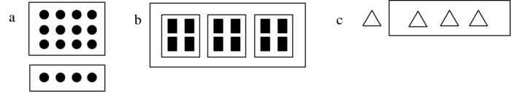

- A teacher marks 10 of her students’ tests every half hour. It takes her one and one half hours to mark all her students’ tests. How many students are in her class?

  - 5
  - 15

  - 20
  - 30

10

38. What fraction is shown by this strip?

A. B. C.
39. Which of these two fractions are equivalent? Draw fraction strips to help you figure this out.

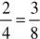
A. 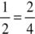 B. 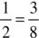 C.

- Since 4 x 10 = 40, and 40 x 5 = 200, then which of the following is true?
  - 14 x 45 = 200

  - 4 x 10 x 40 = 200
  - 4 x 10 x5 = 200

  - 40 x 10 x 5 = 200

- Which two of these fractions are equivalent?

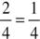
A. 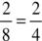 B. 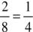 C.

- Which set shows fractions ordered from least to greatest? Draw a picture. A. 1, 1 , 6

 | 4 | 2 | 8
B. | 1 , | 1 , | 1
 | 2 | 4 | 8
C. | 1 , 2 , 3
 | 2 | 4 | 8

11

43. Which number sentence is best represented by the model below?

0 1/4 2/4 3/4 1

  - ¼ + 2/4 = ¾

  - ¾ - ¼ = ¾
  - ¾ - ¼ = 2/4

  - ¾ + 2/4 = ¾

- Which group of fractions is in order from least to greatest? Draw a picture.
  - 2/2, 3/8, 3/4

  - 2/2, 3/4, 3/8

  - 3/4, 3/8, 2/2
  - 3/8, 3/4, 2/2

- Which set shows fractions ordered from least to greatest? Draw a picture.

  - 1/4 , 1/2 , 6/8

  - 1/2 , 1/4 , 1/8

  - 1/2 , 2/4 , 3/8

- Insert < , > , or = in the following blank lines. Draw a picture to help you.

  - 1/5 _____ 1/9

  - 1/6 _____ 1/3

  - 4/5 _____ 2/5

  - 1/2 _____ 2/4

  - 2/6 _____ 4/6

- How many half dollars are there in $4.50?

  - 9 half dollars

  - 18 half dollars

  - 10 half dollars

- Ben, Susan, Alex and Tonya each received ¼ of a dollar. How much is that?

  - $25

  - $.025

  - $0.25

  - $2.5

- Eva has $4.00 to spend on apples. Each apple costs $0.50. How many apples can Eva buy?

  - 2

  - 4

  - 6

  - 8

- Which coins does 0.50 and 0.25 represent?

  - 2 quarters and 2 dimes

  - 1 nickel and 1 quarter

  - 1 half dollar and 1 quarter

  - 5 dimes and 1 nickel

12

- Ron, Nita, Donna and David shared $1.00 equally. What was the exact amount each one received?

  - $0.25

  - $0.30

  - $0.50
  - $0.75

- Michelle has a string which is 3 feet and 8 inches long and John has a string which is two feet and six inches long. How much longer is Michelle’s string?

  - 2 inches
  - 10 inches

  - 1 foot and 2 inches

  - 1 foot and 10 inches

53. _______ days in a week | ______ minutes in an hour | ______ ounces in a pound
_______ months in a year | ______ inches in a foot | ______ seconds in a minute
_______ hours in a day | ______ feet in a yard | ______ weeks in a year

- Mike began his bike ride at 2:40 p.m. and finished the ride at 3:20 p.m. How many minutes did Mike ride?

  - 20 minutes

  - 40 minutes

  - 60 minutes

- Beth was using meter sticks to measure a long table in her classroom. She put the meter sticks end to end three times. The third meter stick went over the edge of the table like this. How long was her table?
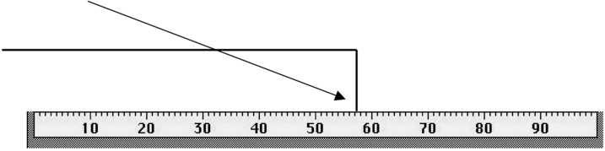

  - 3 Meters

  - 58 Centimeters

  - 58 Meters

  - 2 Meters 58 Centimeters

- What is the date two weeks after June 8?
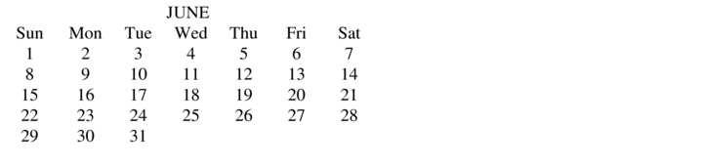

- June 10

- June 15
- June 22

13
57. Mary has a piano recital on May 25. Today is April 28. How long must she wait before the recital day?
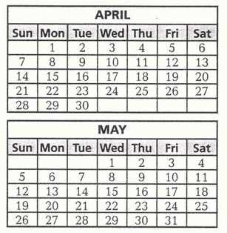

  - 3 weeks 2 days

  - 3 weeks 6 days

  - 4 weeks 2 days

- Joey is meeting Tom at the movies at 1:45. The clock below shows what time it is now. How much time does Joey has to wait before he meets Tom?

  - 4 hours 45 minutes

  - 5 hours 20 minutes

  - 7 hours 20 minutes

- Kim’s little sister just turned 2 years old today. How many months old is her little sister?

  - 2 months

  - 12 months

  - 24 months

- Eric’s disk measures 27 inches. How many feet and inches is that?

  - 1 foot 3 inches

  - 2 feet 3 inches

  - 2 feet 7 inches

- Which of the following represents the greatest length?
  - 10 inches

  - 1 ½ inches

  - 1 ½ feet

  - 1 foot

- Which of the following is the shortest measurement?

  - 1 yard

  - 2 feet

  - 26 inches

  - 1 foot 10 inches
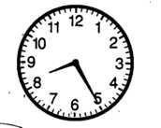
14

63. Write the products. Any that you do not know quickly, practice.

9 | 7 | 5 | 2 | 6 | 7 | 3 | 4 | 5 | 8 | 3 | 11 | 5
x8 | x6 | x10 | x7 | x9 | x7 | x8 | x6 | x9 | x7 | x9 | x7 | x7

9 | 2 | 6 | 4 | 5 | 6 | 4 | 8 | 10 | 3 | 7 | 4 | 7
x6 | x9 | x7 | x11 | x6 | x8 | x9 | x8 | x8 | x6 | x8 | x7 | x9
2 | 3 | 9 | 8 | 2 | 3 | 9 | 7 | 0 | 2 | 5 | 4 | 6
x6 | x12 | x9 | x6 | x8 | x6 | x7 | x8 | x9 | x12 | x8 | x9 | x6

64. The graph below shows the number of pet fish owned by 5 friends. Pet Fish Owned
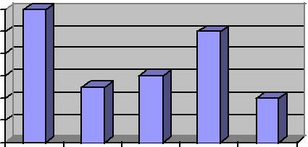
12
10
8
6
4
2
0
James | Doug | Beth | Carly | Luke

What was the minimum number of fish owned by one friend?

- 12

- 10

- 4

- 2

What was the maximum number of fish owned by one friend?
  - 12

  - 10

  - 4

  - 2

- It took Lily 35 hours to drive from Michigan to Texas. How many days and hours did she drive?

  - 1 day 11 hours

  - 1 day 19 hours

  - 3 days 5 hours

- Brad can long jump 1 meter 9 centimeters. How many centimeters is that?

  - 19 centimeters

  - 109 centimeters

  - 1,009 centimeters

- Which temperature is hotter than the boiling point of water?

  - 58º C

  - 98º C

  - 107º C

15

- Chris just put his grape juice in the freezer to make Popsicles. At what temperature will the Popsicles start to freeze?
  - 32º F
  - 0º F
  - -32º F

- Brandon and Ashley are building a snowman on their day off of school. Which is the best

estimate of the outdoor temperature?
  - 20º C

  - 35º C
  - 45º C

- Which thermometer shows the boiling point of water?
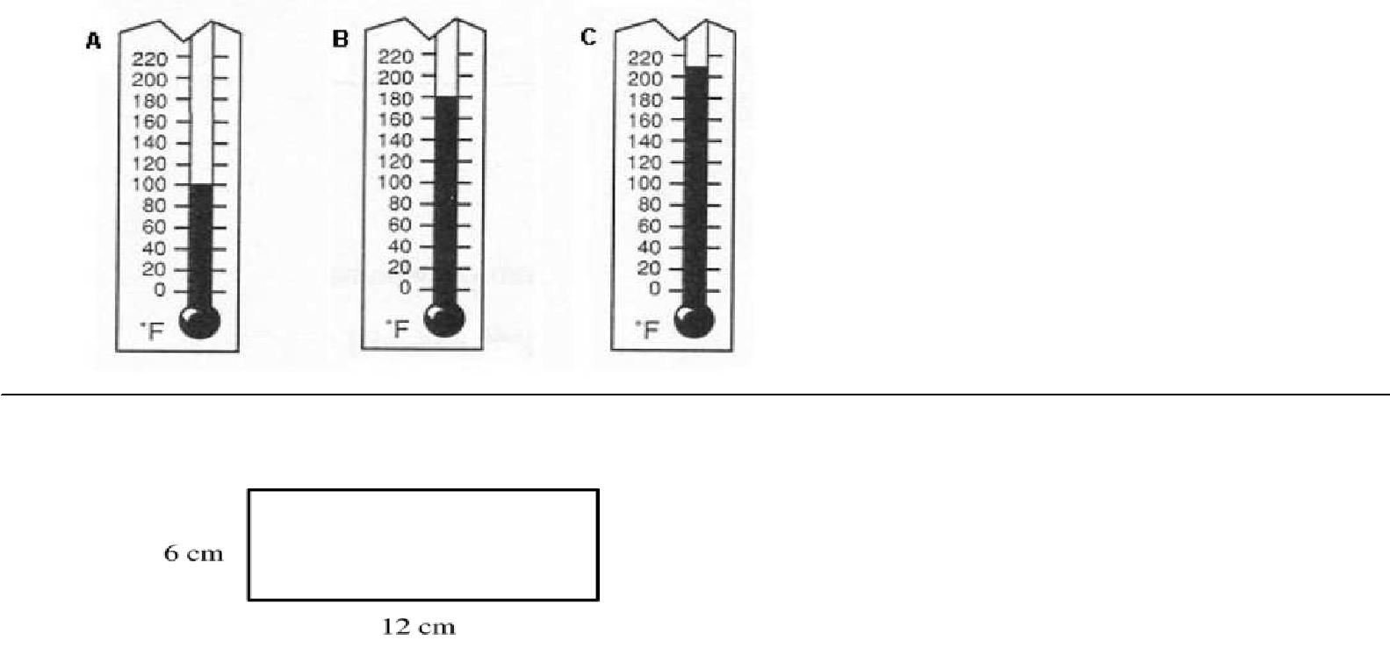

- What is the perimeter of the above rectangle?

  - 18 cm

  - 30 cm

  - 36 cm

- What is the area of the above rectangle?

  - 36 square cm

  - 72 square cm

  - 36 square cm

  - 18 cm

- Draw a rectangle with one side 1 inch and the other side of 3 inches. Then find the perimeter of the rectangle.

  - 3 inches

  - 4 inches

  - 6 inches

  - 8 inches

16
- Find the difference: Remember “bottom bigger better bor row” For example: 52 – 16, the 2 is bigger than the 6, so you need to borrow from the 5 (tens).

28 | 34 | 47 | 75 | 64 | 41 | 69
- 9 | - 7 | -19 | -37 | -14 | - 9 | - 5

75. What is the area of this rectangle?

- 14 cm
- 14 cm²
- 45 cm
- 45 cm²

76. Which of these squares is closer to 1 square centimeter? A or B

- Victor told his friend Kyle that his family moved to Michigan three years and two months ago. Kyle said his family has been living in Michigan for eight years and seven months. How much longer has Kyle’s family b een living in Michigan than Victor’s family?

  - 5 years and 5 months

  - 8 years and 7 months

  - 11 years and 9 months

- Brian’s dad gave him a board that was four feet long and asked Brian to cut off six inches. How long should
the board be when Brian finishes cutting it?

  - 30 inches

  - 42 inches

  - 48 inches

- In gym, Joe jumped 3 feet 4 inches in the long jump. Bob jumped 4 feet 6 inches. How much longer was Bob’s jump than Joe’s jump?

  - 1 foot 2 inches

  - 2 feet 1 inch

  - 7 feet 10 inches

- Mary worked on homework for 20 minutes on Tuesday. She worked on homework for 1 hour and 45 minutes on Wednesday. How much time did she spend doing homework all together on both days?

    - 2 hours

    - 2 hours and 5 minutes

    - 2 hours and 25 minutes

17

- Jim’s cat weighs 8 pounds 7 ounces. Betty’s cat weighs 9 pounds 4 ounces. How much do the two cats weigh together?

  - 18 pounds 11 ounces
  - 17 pounds 3 ounces

  - 17 pounds 11 ounces

  - 18 pounds 3 ounce

- What is 2 minutes and 45 seconds plus 1 minute and 45 seconds?

  - 3 minutes and 30 seconds

  - 4 minutes and 15 seconds

  - 4 minutes and 30 seconds

  - 4 minutes and 45 seconds

- Victoria has 15 dollars and 67 cents. If she borrows 10 dollars and 58 cents from her dad, how much money will she have altogether?

  - 25 dollars

  - 25 dollars and 25 cents

  - 26 dollars

  - 26 dollars and 25 cents

- Andy had $9.85. He bought a toy for $5.52. How much money does Andy have left?

  - $3.24

  - $4.33

  - $5.43

  - $15.37

- Anna had $2.25. She was given $5.50 for her birthday. Anna then spent $4.35 on a new book. How much Money does Anna have now?

  - $1.15

  - $3.25

  - $3.40

  - $7.75

- Lance has $5.62. If he wants to buy a book that costs $16.95, how much more money will Lance need?

  - $5.93

  - $9.66

  - $11.33

  - $22.57

- Write the following numbers in expanded notation. Ex. 432 = 400 + 30 + 2

3,402 = _______ + _______+ _______

5,325 = _______ + _______ + _______ + _______

18

- Sally is 5 years and 5 months old. Her brother, Kevin, is 8 years and 6 months old. How much older is Kevin than Sally?

  - 2 years and 1 month
  - 2 years and 11 months

  - 3 years and 1 month

  - 3 years and 11 months

- Stan wants to buy enough paint to cover an area of one wall of his bedroom. The wall is 8 feet high and 10 feet wide. How many square feet will the paint need to cover?

  - 18 square feet

  - 36 square feet

  - 80 square feet
  - 88 square feet

- Which figure has four sides? (You can look the terms up in a dictionary.)

  - Trapezoid

  - Circle

  - Triangle

  - Pentagon

- How many right triangles would it take to make a square? Answer the question below, then show your
answer by making a drawing.
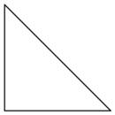

  - 2

  - 3

  - 4

  - 6

- How many triangles would it take to make this hexagon?
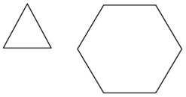

- 2

- 3

- 4

- 6

93.
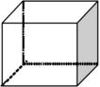

How many vertices are on the cube?
- 6 vertices

- 8 vertices

- 12 vertices

19

How many edges are on the cube?

- 6 edges

- 8 edges

- 12 edges

How many faces are on the cube?

  - 4 faces
  - 6 faces

  - 8 faces

- The shape of on orange is similar to a ______________________.

  - cone

  - cube

  - prism
  - sphere

- What figure has four triangular faces and one square face?
  - Square prism

  - Triangular prism

  - Triangular pyramid

  - Square pyramid

- This chart shows how many points were scored by members of a basketball team. How many players scored 10 or more points?
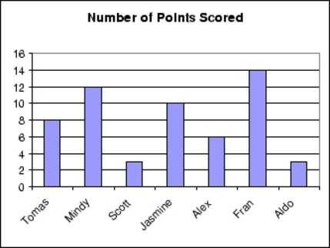

A. 1 B. 2 C. 3 D. 4

- 133 fourth grade students were asked what they drink with breakfast in the morning. Here is a bar graph of their responses.
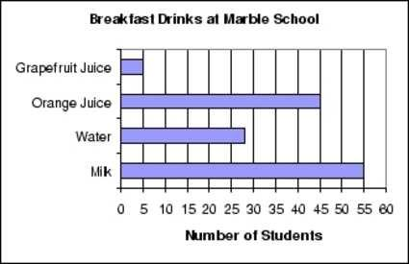

What is the range of this data?
- 28

- 50

- 55

- 60

20
What is the mean of this data? You can use a calculator for this.

  - About 133

  - About 33

  - About 28

- Did the museum or the aquarium have more visitors for the week?
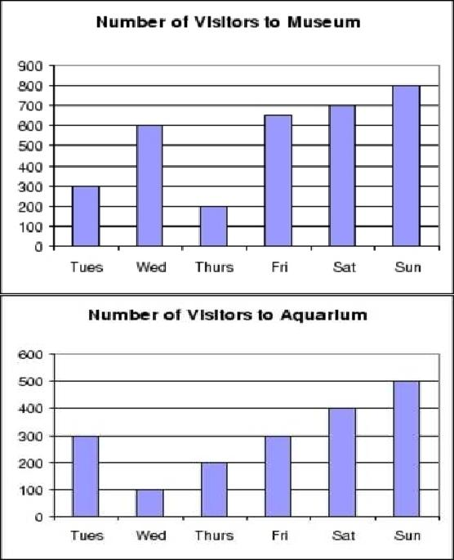

A. | Aquarium |  | C. They are the same.
B. | Museum |  | D. There is not enough information to decide.
99. Solve each of these without using a calculator:
4 x 6 |  | =______ | 8 x 8 =________ |  | 2 x 7 =_______
2 x 9 |  | = ______ | 5 x 5 =________ |  | 9 x 6 =_______
8 x 5 =______ |  |  | 2 x 2 =________ |  | 3 x 4 =_______
32 | ÷ 4 = ______ |  | 7 x 7 | = ________ | 56 ÷ 7 = ______
72 | ÷ 9 = ______ |  | 18 ÷ 2 =_______ |  | 3 x 8 =_______
45 | ÷ 9 = ______ |  | 4 x 4 | =________ | 8 x 7 =_______
24 | ÷ 3 =_______ |  | 3 x 3 | =________ | 3 x 8 =_______
4 x 6 |  | =________ | 6 x 6 =________ |  | 1 x 9 =_______

100. What is 500 x 8? Explain how you figured this out, without using a calculator.

21

101. 23 children are waiting in line for a roller coaster. There are 5 carts that hold 4 people. Will all the children be able to ride together at the same time?

- Yes
- No

Explain your answer.

102. Place the following fractions where they belong on the number line:

2/4 3/4 1/4

103. Place these fractions where they belong on the ruler:

1/2 3/4 1/4
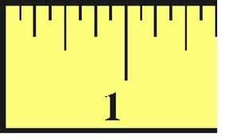

104. Label the following lines: (You can look the terms up in a dictionary if needed.)

A. | Parallel | A. | Parallel
B. | Intersecting | B. | Intersecting
C. | Perpendicular | C. | Perpendicular

105. Which two faces of this cereal box appear to be parallel?

- Top and right side

- Front and bottom

- Front and back

- Bottom and left side

22

106. Solve the following:
1 x 9 = ______ | 3 x 6 =________ | 9 x 7 =_______ | 6 x 2 =_______
8 x 6 =______ | 2 x 2 =________ | 3 x 8 =_______ | 9 x 9 =_______
24 ÷ 3 = ______ | 7 x 7 = ________ | 56 ÷ 7 = ______ | 4 x 0 =_______
48 ÷ 6 = ______ | 18 ÷ 6 =_______ | 7 x 3 =_______ | 7 x 7 =_______

107. Brent planted vegetables in the square garden pictured below.

5 feet

What is the area of the garden? (Area = length x width)

  - 10 square feet

  - 20 square feet

  - 25 square feet

  - 55 square feet

- What is the perimeter of the shape pictured below?

2 ft.

15 ft.

- 17 ft.

- 19 ft.

- 30 ft.

- 34 ft.

What is the area of the picture above?

- 17 sq. ft.

- 19 sq. ft.

- 30 sq. ft.

- 34 sq. ft.

23

- Don wants to buy enough seed to grow grass in the patch of lawn that is 10 feet long and 9 feet wide. How many square feet is her patch of lawn? Show your work.

Answer_________________

110. Find the products.

Any multiplication problem you do not know quickly please practice on flash cards.

6 | 4 | 7 | 5 | 12 | 3 | 6 | 3 | 0 | 7 | 5 | 6 | 3 | 8
x2 | x4 | x2 | x4 | x0 | x5 | x3 | x8 | x8 | x3 | x5 | x4 | x9 | x3

6 | 2 | 3 | 8 | 7 | 12 | 8 | 3 | 11 | 7 | 9 | 4 | 4 | 9
x5 | x12 | x6 | x2 | x5 | x1 | x4 | x7 | x4 | x6 | x2 | x8 | x6 | x3

4 | 5 | 0 | 5 | 9 | 5 | 2 | 9 | 5 | 11 | 5 | 9 | 7 | 7
x7 | x0 | x3 | x8 | x4 | x7 | x1 | x5 | x6 | x5 | x9 | x8 | x7 | x9

8 | 6 | 8 | 1 | 9 | 9 | 8 | 1 | 9 | 2 | 1 | 3 | 12 | 1
x8 | x6 | x7 | x2 | x6 | x9 | x6 | x9 | x1 | x5 | x1 | x4 | x3 | x3

8 | 8 | 12 | 8 | 12 | 5 | 3 | 4 | 2 | 7 | 6 | 2 | 6 | 12
x0 | x1 | x4 | x9 | x0 | x1 | x2 | x0 | x2 | x1 | x8 | x6 | x7 | x5

8 | 4 | 2 | 9 | 12 | 11 | 2 | 7 | 0 | 6 | 1 | 5 | 3 | 2
x5 | x1 | x8 | x7 | x8 | x6 | x9 | x4 | x2 | x9 | x0 | x2 | x3 | x4

4 | 12 | 4 | 4 | 1 | 2 | 11 | 6 | 7 | 5 | 2 | 1 | 4 | 11
X9 | x6 | x2 | x3 | x4 | x3 | x7 | x1 | x8 | x3 | x7 | x8 | x5 | x4

24

- Kayla read a book that was 54 pages long. She read 6 pages each day. Which number sentence below can be used to determine the total number of days it took Kayla to read the entire book?

  - 54 – 6 = ?
  - 54 ÷ 6 = ?

  - 54 + 6 = ?
  - 54 x 6 = ?

- All the sections of the figure below are the same size and shape. What fractional part of the figure

is shaded?

  - 0.5
  - 0.25

  - 3/8

  - 4/8

- Which of the following fractions has a numerator of 3?

  - 1/5

  - 2/3
  - 3/5
  - 4/5

- Bonnie and 3 friends shared $2.00 equally. What is the total amount each of them received?

  - $6.00
  - $1.00

  - $0.75
  - $0.50

- What time was it 3 hours ago if it is now 2:00 pm?

  - 10:00 am

  - 11:00 am
  - 5:00 pm

  - 11:00 pm

- What is the perimeter of a rectangle that has a length of 6 inches and a width of 5 inches?

  - 11 inches
  - 22 inches

  - 30 inches

  - 36 inches

25

117. Find the quotients.
__ |  | ___ | ___ | ___ | ___ | ___ | ___ | ___ | ___ | ___ | ___ | ___ | ___ | ___
2)2 |  | 3)9 | 8)32 | 7)49 | 5)10 | 4)0 | 1)1 | 4)8 | 2)12 | 9)54 | 1)3 | 1)2 | 2)4 | 2)14
__ |  | ___ | ___ | ___ | ___ | ___ | ___ | ___ | ___ | ___ | ___ | ___ | ___
8)8 |  | 7)63 | 8)40 | 5)0 | 4)4 | 4)12 | 9)45 | 9)63 | 6)6 | 3)12 | 1)7 | 3)0 | 1)9
__ |  | ___ | ___ | ___ | ___ | ___ | ___ | ___ | ___ | ___ | ___ | ___ | ___
2)16 |  | 3)3 | 3)15 | 5)20 | 3)18 | 3)6 | 5)15 | 7)0 | 9)27 | 4)16 | 7)21 | 4)20 | 7)28
__ |  | ___ | ___ | ___ | ___ | ___ | ___ | ___ | ___ | ___ | ___ | ___ | ___
8)16 |  | 3)21 | 9)18 | 4)24 | 2)6 | 1)8 | 5)35 | 7)35 | 3)27 | 6)36 | 3)24 | 2)0 | 4)32
__ |  | ___ | ___ | ___ | ___ | ___ | ___ | ___ | ___ | ___ | ___ | ___ | ___
9)9 |  | 4)36 | 6)42 | 5)40 | 8)64 | 7)14 | 6)30 | 8)56 | 1)5 | 4)28 | 7)56 | 8)24 | 6)24
81 ÷ | 9= ______ |  |  | 48 ÷ 6 = ______ |  |  |  | 18 ÷ 6 = ______ |  |  | 42 ÷ 7 = ______
10 ÷ | 2 = ______ |  |  | 54 ÷ 6 =_______ |  |  |  | 36 ÷ 9 = ______ |  |  | 45 ÷ 5 = ______
72 ÷ | 8 = ______ |  |  | 8 ÷ 2 =_______ |  |  |  | 72 ÷ 9 = ______ |  |  | 6 ÷ 1 =_______
25 ÷ | 5 = ______ |  |  | 5 ÷ 5 = ______ |  |  |  |  | 18 ÷ 2 = ______ |  |  | 30 ÷ 5 =_______
12 ÷ | 6 = ______ |  |  | 4 ÷ 1 = ______ |  |  |  |  | 48 ÷ 8 = ______ |  |  | 7 ÷ 7 = ______

118. Write the following fractions in decimal form. Remember: |  | . tenths hundredths
4/10 = _________ 8/10 = __________ | 23/100 =_________ | 56/100=___________
8/100 = ________ 5/10 = __________ | 66/100 = _________ | 2/10 = ___________

26

- Find the sum or difference: Watch signs! When subtracting think: “Bottom bigger better borrow”

135 | 546 | 71 | 50 | 304 | 63 | 426
+479 | +137 | - 18 | -26 | +235 | -42 | -135

17 | 54 | 135 | 3.2 | 8.8 | 8.1 | 4.8
+18 | -39 | - 53 | +2.8 | +1.3 | -5.7 | -2.6

2.29 | 553 | 113 | 86 | 8.04 | 13.06 | 8.9
- 0.43 | - 86 | +54 | +73 | - 0.56 | +6.72 | - 4.7

120. Match the following: Draw a line to make a match.

Four tenths | .08
Eight hundredths | .3
64 hundredths | .4
3 tenths | .64

- Write the following in fraction and decimal form: Eight tenths = __________ = ___________
Twenty-seven hundredths = __________ = __________

Five hundredths = __________ = __________

Five tenths = ___________ = ___________

- Brent and Monique watched a movie without a break. The movie started at 1:15 p.m. and ended at 2:45 p.m.
How long was the movie?

- 1 hour 15 minutes

- 1 hour 30 minutes

- 1 hour 45 minutes

- 4 hours

27

- Which of the following is true?

  - 25 meters > 25 centimeters

  - 25 meters < 25 centimeters
  - 250 centimeters > 25 meters

  - 25 centimeters = 25 meters

- Which shape has 12 edges, 8 vertices, and 6 faces?

  - Triangular prism
  - Triangular pyramid

  - Rectangular prism

  - Rectangular pyramid

- Write the number 365 thousand 243 in standard form. ______________

- Write the following number in standard form: 3,000 + 500 + 30 + 2 = ________________

- Write the following number in standard form: 5,000 + 200 + 3 = _____________

- Write the following in expanded notation: 8,325 = __________________________________________________

- Write the following in expanded notation: 6,023 = __________________________________________________

CONGRATULATIONS!!! You have completed the summer math packet. You are now ready for 4th grade success! Please turn this packet into your 4th grade teacher, the first week of school.

