1

Summer Math Reinforcement Packet
Students Entering into 6th Grade

Our fifth graders had a busy year learning new math skills. Mastery of all these skills is extremely important in order to develop a solid math foundation. The sixth grade math program will add onto these fifth grade skills, so any time spent learning or reinforcing these concepts will be very beneficial for your child. Each year builds upon the previous year’s skills in math. Any areas your child has difficulty, you may want to give them additional practice. Student mastery of the basic math skills is as important to success in future mathematical procedures and reasoning as learning the alphabet is to reading and writing.

Have your child complete one page (one side), three times a week of the math packet. Please return this completed packet to your sixth grade teacher.

After your child has completed the math problems and you feel your child is still struggling on a certain concept and needs further practice, you can visit some of the web sites listed on the next page. You can also make up problems of your own for additional practice.

Also included is an answer key on different color paper for parents use only in assisting your child.

Enjoy your summer!!

Reminder - Practicing multiplication (up to 12) and division facts are VERY important!

2

FIFTH GRADE

GRADE LEVEL EXPECTATIONS IN MATHMATICS

When entering sixth grade this is what is expected that your child should already know.

- Understand the meaning of division of whole numbers and how to check your answers through multiplication. Ex. 34 ÷ 5 = 6 r4, so 5 x 6 = 30 + 4 = 34.

- Fluently multiply a multi-digit number by a two-digit number.
- Divide fluently up to a four-digit number by a two-digit number.

- Find the prime factorization of numbers from 2 through 50, express in exponential notation. Ex. 24 = 2 x 2 x 2 x 3 = 2³ x 3¹

- Understand a fraction as a statement of division. Ex. 2 ÷ 3 = ²/
- Multiply and divide 2 fractions and understand fact families.

- Divide a fraction by a whole number and a whole number by a fraction.

- Add and subtraction fractions using unlike denominators, using common denominators.
- Multiply and divide by 10’s, 100’s and 1,000’s using mental mat h.

- Multiply up to 2-digits and decimals up to 2 digits.

- Solve story problems with adding, subtracting, multiplying, dividing fractions and decimals.

  - Solve for the unknown in equations such as ¼ + x = 7/12.

- Express fractions and decimals as percentages and vice versa.

- Express ratios in several ways. Ex. 3 cups to 5 people, 3 : 5, 3/5; find equivalent ratios.

- Recognize the equivalence of 1 liter, 1,000 ml and 1,000 cm³ and conversion between.

- Understand volume; cubic centimeter (cm³), cubic meter (m³), cubic inches (in³), cubic foot, (ft³), and cubic yard (yd³). Be able to compare one cubic inch to one cubic foot and one cubic centimeter to one cubic meter.

- Convert measurements of length, weight, area, volume, and time within metric to metric and within standard measurement to standard measurement.

- Know how to calculate the area of a triangle – A = ½ bh and area of a parallelogram A = bh.

- Calculate the volume of a cube and rectangular prism.

- Understand that the measurement of 90˚, 180˚, 270˚, and 360˚ are associated respectively with ¼, ½, and ¾, and full turns.

- Measure angles with a protractor and classify them as acute, right, obtuse and straight.

- Find unknown angles in problems with angles on a straight line, vertical angles and surrounding a point.

- Know angles on a straight line = 180˚ and angles surrounding a point add up to 360˚.

- Know the sum of the interior angles of a triangle is 180 ˚ and the sum of the interior angles of a quadrilateral is 360˚.

- Read, interpret, and solve problems involving line graphs.

- Construct line graphs from tables of data; including axis labels and scale.

- Calculate and interpret the mead and mode of a given set of data.

- Solve multi-step problems involving means,

3

Excellent websites for fun learning and reinforcement of math skills:

www.wildmath.com Select “Play the game”. Select addition, subtraction or multiplication and grade. You can race to beat your time.

www.harcourtschool.com | Click the red box, select math, select HSPMath, select Michigan, click on the
 | “5” ball or “6” ball for a challenge. Select a game.
www.aplusmath.com | Go under “Flashcards” or “Game Room” on the left s ide of the screen.
 | They can practice adding, subtracting and multiplying. Very important to
 | know the addition, subtraction and multiplication facts from memorization
 | or within a couple seconds.
www.mathisfun.com | Select numbers then Math Trainer for adding, subtracting and multiplication.
 | Or at the home screen select games and pick a game to play.
www.eduplace.com | Select your state – “Michigan” press submit. | Select the student tab
 | then click on the “mathematics” rectangle. Click in the cent er book
 | “Houghton Mifflin Math 2007”, Click on “Grade 5”. Select any games.
 | Extra Help and Extra Practice is good, also eGames.
www.illuminations.nctm.org Select activities then select grade level. Click on Search.
www.aaamath.com | At the top pick “Fifth” or “Sixth” for a chall | enge. Choose any of the
 | activities like multiplication then select “play” option toward the top
 | of the screen. 20 Questions and Countdown games are good ones.

www.funbrain.com Lots of fun games to choose from.

Other games and activities you can play:

- Take a deck of cards and remove the face cards (kings, queens, jacks). Aces are one. Divide the cards evenly among 2 players. Each player flips over a card. The first one to add the 2 numbers correctly the fastest wins the cards. After going through the pile of cards, the player with the most cards wins. You can do a multiplication version also.

4

TERMS

Edges: This is all the straight lines of a figure. Like the edge of a desk.
Faces: This is the flat surface of a figure.

Vertex: This is all the corners of a figure.

Right angle: An angle at 90º like a corner of a piece of paper.
Acute angle: An angle smaller than a right angle.

Obtuse angle: An angle larger than a right angle.

Volume: volume is length x width x height

Perimeter: You add up all the sides. (You are adding all lengths of the outer edges together.) Area: Area of a square or rectangle = length (l) x width (w) answer is written in “square inches”
(or whatever the measurement is)

Area of a parallelogram is length x height. Answer written in “square inches” (or whatever measurement)

Height

Length

Area of a triangle is ½ base x height or (base x height) ÷ 2 Triangle: Sum of the 3 interior angles of a triangle is always 180º.
Quadrilateral: Sum of the 4 interior angles in a quadrilateral is always 360º.

Mean: This is average. You add the set of number values and divide it by how many numbers you have.

Median: Arrange numbers from smallest to largest. What number is in the middle? That is the Median number.
Mode: What number occurs most often? This number is the mode.

Range: Subtract the largest number in the group from the smallest number in the group. This number is the range.

Conversion:
60 seconds = 1 minute | 24 hours = 1 day | 16 ounces = 1 pound
60 minutes = 1 hour | 12 months = 1 year | 2,000 pounds = 1 ton
365 days = 1 year | 52 weeks = 1 year
12 inches = 1 foot | 10 millimeter = 1 centimeter (approx. 3 ½ centimeters = 1 inch)
3 feet = 1 yard | 100 centimeter = 1 meter | (approx. 1 meter = 1 yard)
5,280 feet = 1 mile | Liter to milliliter is the same as meter to millimeter

Fractions:

Adding and subtracting: you need to have the same common denominator (bottom) then, you + or – the numerators (top).

Multiplying: you multiply both numerators then you multiply both denominators. Convert to improper fractions if needed, no mixed numbers.

Dividing: convert to improper fractions; flip the second fraction in the equation then multiply.

5

Entering 6th Grade Summer Math Packet

First Name: ______________________________Last Name: ______________________________

6th Grade Teacher: ________________________

I have checked the work completed:__________________________________________________

Parent Signature

1. Find the products. This page should be completed in 3 minutes no more than 4 minutes.

Have someone time you. Any multiplication problem you do not know quickly, practice on flash cards.

6 | 4 | 7 | 5 | 12 | 3 | 6 | 3 | 0 | 7 | 5 | 6 | 3 | 8
x2 | x4 | x2 | x4 | x0 | x5 | x3 | x8 | x8 | x3 | x5 | x4 | x9 | x3

6 | 2 | 3 | 8 | 7 | 12 | 8 | 3 | 11 | 7 | 9 | 4 | 4 | 9
x5 | x12 | x6 | x2 | x5 | x1 | x4 | x7 | x4 | x6 | x2 | x8 | x6 | x3

4 | 5 | 0 | 5 | 9 | 5 | 2 | 9 | 5 | 11 | 5 | 9 | 7 | 7
x7 | x0 | x3 | x8 | x4 | x7 | x1 | x5 | x6 | x5 | x9 | x8 | x7 | x9

8 | 6 | 8 | 1 | 9 | 9 | 8 | 1 | 9 | 2 | 1 | 3 | 12 | 1
x8 | x6 | x7 | x2 | x6 | x9 | x6 | x9 | x1 | x5 | x1 | x4 | x3 | x3

8 | 8 | 12 | 8 | 12 | 5 | 3 | 4 | 2 | 7 | 6 | 2 | 6 | 12
x0 | x1 | x4 | x9 | x0 | x1 | x2 | x0 | x2 | x1 | x8 | x6 | x7 | x5

8 | 4 | 2 | 9 | 12 | 11 | 2 | 7 | 0 | 6 | 1 | 5 | 3 | 2
x5 | x1 | x8 | x7 | x8 | x6 | x9 | x4 | x2 | x9 | x0 | x2 | x3 | x4

4 | 12 | 4 | 4 | 1 | 2 | 11 | 6 | 7 | 5 | 2 | 1 | 4 | 11
X9 | x6 | x2 | x3 | x4 | x3 | x7 | x1 | x8 | x3 | x7 | x8 | x5 | x4

6

2. Find the quotients. This page should be completed in 3 no more than 4 minutes. Practice any problems you do not know instantly. Think of the multiplication fact family. The better you know your multiplication facts the easier division will be.

__ | ___ | ___ | ___ | ___ | ___ | ___ | ___ | ___ | ___ | ___ | ___ | ___
2)2 | 3)9 | 8)32 | 7)49 | 5)10 | 4)0 | 1)1 | 4)8 | 2)12 | 9)54 | 1)3 | 1)2 | 2)4
__ | ___ | ___ | ___ | ___ | ___ | ___ | ___ | ___ | ___ | ___ | ___ | ___
8)8 | 7)63 | 8)40 | 5)0 | 4)4 | 4)12 | 9)45 | 9)63 | 6)6 | 3)12 | 1)7 | 3)0 | 1)9
__ | ___ | ___ | ___ | ___ | ___ | ___ | ___ | ___ | ___ | ___ | ___ | ___
2)16 | 3)3 | 3)15 | 5)20 | 3)18 | 3)6 | 5)15 | 7)0 | 9)27 | 4)16 | 7)21 | 4)20 | 7)28
__ | ___ | ___ | ___ | ___ | ___ | ___ | ___ | ___ | ___ | ___ | ___ | ___
8)16 | 3)21 | 9)18 | 4)24 | 2)6 | 1)8 | 5)35 | 7)35 | 3)27 | 6)36 | 3)24 | 2)0 | 4)32
__ | ___ | ___ | ___ | ___ | ___ | ___ | ___ | ___ | ___ | ___ | ___ | ___
9)9 | 4)36 | 6)42 | 5)40 | 8)64 | 7)14 | 6)30 | 8)56 | 1)5 | 4)28 | 7)56 | 8)24 | 6)24
81 ÷ 9= ______ |  |  | 48 ÷ 6 = ______ |  |  |  | 18 ÷ 6 = ______ |  |  | 42 ÷ 7 = ______
10 ÷ 2 = ______ |  |  | 54 ÷ 6 =_______ |  |  |  | 36 ÷ 9 = ______ |  |  | 45 ÷ 5 = ______

72 ÷ 8 = ______ 8 ÷ 2 =_______ 72 ÷ 9 = ______ 6 ÷ 1 =_______

25 ÷ 5 = ______ 5 ÷ 5 = ______ 18 ÷ 2 = ______ 30 ÷ 5 =_______

12 ÷ 1 = _______ 49 ÷ 7 = ______ 21 ÷ 3 = ______ 36 ÷ 6 = _______

7

Select the one best answer for each question. DO NOT use a calculator in completing this packet.

- Jennie was assigned this problem:

146

x25

She worked out the problem in this way:

146 x 2 = 292, and 146 x 5 = 730. Then she added 292 + 730. She knew that her answer was wrong because her answer seemed too small. What should she have done differently?

  - She should have multiplied 146 x 50 instead of 146 x 50.

  - She should have multiplied 146 x 20 instead of 146 x 2.
  - She should have multiplied 146 x 200 instead of 146 x 2.

  - She should have multiplied 140 x 2 instead of 146 x 2.

- Which of the following is the correct computation of 4,063 x 52? (Do not use a calculator.)

A. |  |  | 4,063 |  | B. | 4,063 | C. | 4,063 | D. | 4,063
 |  | x | 52 |  |  | x 52 |  | x 52 |  | x 52
 |  |  | 8026 |  |  | 8126 |  | 8126 |  | 8126
 | 200150 |  |  |  |  | 20315 |  | 2030150 |  | 203150
208176 |  |  |  |  |  | 28441 |  | 2038276 |  | 211276

- Samantha has to read a book that is 525 pages long. She has 21 days to read the book. How many pages will she need to read each day to finish on time?

  - 21

  - 25

  - 546

  - 11,025

- Andrew’s family is going on vacation across the United States. They traveled 515 miles every day for 17 days. How many miles did they travel in all?

  - 532

  - 4,120

  - 8,165

  - 8,755

- Three classes of 25 students collected 8 cans of soup from each student. The cans were then to be divided between 4 charities. How many cans of soup went to each charity?

  - 50

  - 108

  - 150

  - 800

8

- Brent has a collection of 84 Bobble Head trophies he needs to box up for the move to his new home. He can fit 7 trophies into one box. How many boxes will Brent need?

  - 10

  - 12

  - 13
  - 21

- Kayla has 12 cousins. She received $15.00 from each cousin for her birthday. How much money did she receive in all?

  - $27
  - $120

  - $150

  - $180

- The 5th grade is going on a trip to the state park. There are 1,012 students going. Each bus can hold 44 students. How many busses will they need? (Do not use a calculator.)

  - 23

  - 26

  - 50

  - 968

- Find 1717 ÷ 17. Do not use a calculator.

  - 11

  - 101

  - 107

  - 1001

- Solve 4806 ÷ 15 without using a calculator, show your work.

  - 32

  - 320 r 6

  - 320 r 4

  - 320

- Solve 647 ÷ 21. Do not use a calculator, show your work.

  - 3 r 11

  - 3 r 21

  - 30 r 8

  - 30 r 17

9

- Use a factor tree to find the prime factorization of the composite number 50. Which answer expresses the number in exponential notation (powers)?

  - A. 2 x 5²
  - 2² x 5²
  - 2³ x 5³

  - 10 x 5

- Find the prime factorization for 84.

  - 2 x 42

  - 7 x 2 x 2 x 3

  - 7 x 4 x 3

  - 7 x 12

- Find the prime factorization for the number 48 expressed in exponential notation.

  - 3¹ x 2⁴

  - 6 x 8¹
  - 3 x 2⁴ x 4
  - 3 x 2² x 4

- Which drawing would you use to find the product of these two fractions?
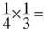

  - Drawing a

  - Drawing b

  - Drawing c

  - Drawing d

- Solve this equation:

  - 2
  - 3

  - 2/6
  - 2/9
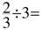
10

19. Solve the following:

1/3 ÷ 4 =
- 4/3

- 1/7

- 1/12
- 12

20. Solve this equation: 2 ÷ ¼ =

  - 1/2

  - 2/4
  - 2

  - 8

- Mrs. Lovell’s class is baking cookies. They need 3 3/5 pounds of sugar and 5 1/3 pounds of flour. When they mix the sugar and flour together, how many pounds will they have altogether?

  - 8 4/8 pounds

  - 8 ¾ pounds
  - 9 3/15 pounds

  - 8 14/15 pounds

- Choose the correct answer for this problem:

7/9 – 3/8 =

  - 10/17

  - 29/72
  - 56/27

  - 21/72

- Choose the correct answer for this problem:

3/7 + 2/9 =

  - 5/16
  - 41/63

  - 6/63
  - 18/14

- Tom had 7/12 of a pizza. His little sister came along and took 2/5 of his pizza away. How much pizza does Tom have left?

  - 11/60

  - 5/7

  - 9/17

  - 5/60

11

- Jill has ¾ of a yard of ribbon. Tammy has 4/7 of a ya rd. How much do they have together?

  - 7/11 of a yard

  - 40/28 of a yard

  - 1/3 of a yard

  - 37/28 of a yard

26. Paul had 3 7/8 cups of milk. He gave 1 ¾ cups of milk to his cat. How much milk did he have left? Show your work.

  - 2 cups

  - 2 1/8 cups
  - 2 4/4 cups

  - 1 7/8 cups

- Nancy ate 1/3 of a pizza and Gabe ate ¼ of the pizza. How much of the whole pizza is left?

  - 7/12

  - 5/12

  - 2/7

  - 6/7

28. Choose the correct answer for this problem: 5/4 – 3/12 =

  - 2/12

  - 12/12
  - 9/24

  - 2/48

- Patty brought ½ of a cake to class, and Joe brought ¾ of a cake on the same day. How much cake did the class have altogether? Show your work.

  - ¼ cake

  - 1 cake

  - 4/6 cake

  - 1 ¼ cake

- Don has $12.32 in his piggy bank. He collects and returns pop cans for $3.70. Approximately how much money does he have together? (Round the answer to the nearest whole dollar.)

  - $8

  - $15

  - $16

  - $17

12

- Michelle earned $5.00 for every hour she babysat. Last week she babysat for 8 hours. She spent $12.00 of the money she earned. Which expression could be used to find how much money she had left?

  - $5.00 x 8 + $12.00

  - $5.00 + 8 - $12.00
  - $5.00 x 8 - $12.00

  - $5.00 x 8 ÷ $12.00

- Ten fourth graders will each eat one – fourth of a pizza. How many pizzas need to be ordered for the ten students?

  - 2 pizzas

  - 3 pizzas

  - 4 pizzas

  - 5 pizzas

- In the equation 1/3 + x = 5/12, what does x = ?

  - 4/9

  - 5/4

  - 1/12

  - 3/12

- Solve for x:

11/12 – x = ¼

- 10/12

- 8/12

- 10/8

- 3/4

35. Solve for x: x + 1/3 = ¾

  - 2/1

  - 5/12

  - 4/7

  - 13/12

- Exactly 1/20 of the students in Mr. Nebel’s class have a bird. What percentage of his students has a bird?

  - 0.05%

  - 1%

  - 5%

  - 20%

13

- Seven out of ten students in Ms. Allington’s class completed the summer math packet. What percentage of students completed the packet?

  - 7 %

  - 70 %

C. .7 %
  - 14%

- How much larger is one cubic foot than one cubic inch?

  - 3 times larger

  - 15 times larger
  - 144 times larger

  - 1728 times larger

- Which of the following is NOT equivalent?

  - 1 ton = 2000 pounds

  - 1 mile = 5200 feet

  - 9 feet = 3 yards

  - 60 minutes = 3600 seconds

- Sharon reads the juice bottle and finds that it contains 1.89 liters of juice. His cup only holds 240 milliliters so he wants to convert 1.89 liters to milliliters. The bottle contains how many milliliters?

  - 1.89 milliliters

  - 18.9 milliliters

  - 189 milliliters

  - 1890 milliliters

- Solve the following:

2,749 | 156 | 837 | 368
x 68 | x 78 | x 46 | x 20

- Which is true?

  - 0.07 is ten times greater than 0.7

  - 0.070 is ten times greater than 0.007

  - 0.070 is equal to 0.0070

  - 0.07 is seven times greater than 0.70

14

- Using the rectangle method, what is the area of this triangle?

  - 2 square units
  - 4 square units

  - 6 square units

  - 8 square units

- Which statement is true about the relationship between the areas of these two rectangles?
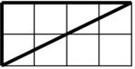
 | Rectangle A | Rectangle B
4 units |  |  |  | 4 units
 | 10 units |  | 2 units

- Rectangle A has twice the area of Rectangle B.

- Rectangle A has 5 times the area of Rectangle B.

- Rectangle A has one-half the area of Rectangle B.

- Rectangle A has one-fifth the area of Rectangle B.

45. What is the area of this quadrilateral? Area = height x width

12 feet
|
3 ft.
|

  - 30 feet

  - 30 square feet

  - 36 feet

  - 36 square feet

- Which of the following is a true statement?

  - 0.003 is 1/3 the value of 0.03

  - 0.003 is 3 times the value of 0.03

  - 0.003 is 1/10 the value of 0.03

  - 0.003 is 10 times the value of 0.03

15

- How do the areas of these two figures compare? Select your answer, then explain why you think you answer is correct.
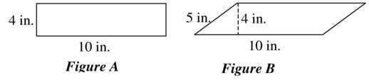

- The area of Figure A is greater than the area of Figure B.

- The area of Figure B is greater than the area of Figure A.

- The area of Figure A is equal to the area of Figure B.

- The area of Figure B is twice the area of Figure A.

48. Use the diagram to find the area of the triangle ZMT.
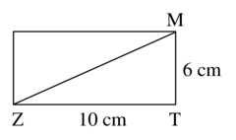

- 16 square cm

- 30 square cm

- 32 square cm

- 60 square cm

49. What is the area of this triangle?
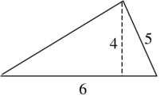

- A = (5x4) ÷ 2
- A = (5x5) ÷ 2

- A = (6x5) ÷ 2
- A = (6x4) ÷ 2

16

- The area of the triangle can be found using the formula A = bh ÷ 2. Which of the following figures is labeled correctly to apply this formula?
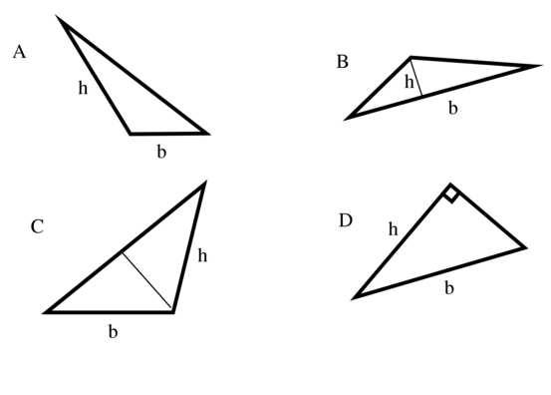

51. Solve each of these without using a calculator:
4 x 6 =______ |  |  |  | 8 x 8 =________ |  |  | 6 x7 =_______
2 x 9 = ______ |  |  |  | 5 x 5 =________ |  |  | 9 x 6 =_______
8 x 5 =______ |  |  |  | 2 x 2 =________ |  |  | 3 x 4 =_______
32 | ÷ 4 | = ______ |  | 7 x 7 | = ________ |  | 56 ÷ 7 = ______
72 | ÷ 9 | = ______ |  | 18 ÷ 2 =_______ |  |  | 3 x 8 =_______
45 | ÷ 9 | = ______ |  | 4 x 4 | =________ |  | 8 x 7 =_______
24 | ÷ 3 | =_______ |  | 3 x 3 | =________ |  | 3 x 8 =_______
52. Find the sum or difference. Watch the signs.
501 |  | 607 | 850 | 3,031 |  | 953 | 700 | 387
- 247 |  | -217 | +268 | -1,441 |  | +529 | - 202 | +487

- Find the difference 701.02 – 234.12. Show your work

____________________

17

54. What is the area in square centimeters of the triangle pictured below?
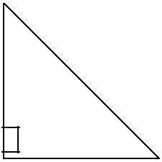

16 cm.

  - cm.

- 28 square cm.

- 56 square cm.
- 96 square cm.

- 192 square cm.

55. What is the area of this triangle?
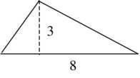

- 7

- 11

- 12

- 24

56. What is the area of this triangle? (A = bh÷2)
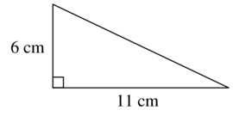

  - 17 sq. cm.

  - 33 sq. cm.

  - 66 sq. cm.

  - 132 sq. cm

- The fraction 4/20 equals what percentage?

  - 4 %

  - 20%

  - 25%
  - 40%

18

58. Use the diagram to find the area of the parallelogram. (A = bh)
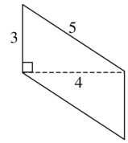

- 12 square centimeters

- 15 square centimeters
- 20 square centimeters
- 60 square centimeters

59. Find the area of the parallelogram below.
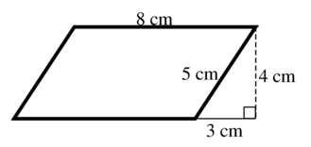

- 12 cm²

- 24 cm²

- 32 cm²
- 40 cm²

60. What is the area of the parallelogram shown below?

4 cm.

10 cm.

- 14 cm²

- 20 cm²

- 28 cm²
- 40 cm²

- The area of this parallelogram is 24 square units. The base of the parallelogram is 8 units. What is the height of the figure? Circle your answer below and draw the height on the parallelogram.

- 2 units

- 3 units

- 4 units

- 6 units

19

- The area of a parallelogram is 36 square inches. All of the following are possible bases and heights for this figure EXCEPT:

- 1 inch by 36 inches

- 3 inches by 12 inches

- 4 inches by 9 inches
- 5 inches by 7 inches

- The base of the parallelogram below is 9 centimeters. The area is 72 square centimeters. What must the height of the parallelogram by? (A = bh)
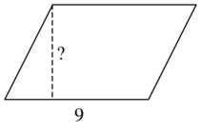

- 6 centimeters

- 7 centimeters

- 8 centimeters

- 9 centimeters

- Using unit cubes, build a solid that is 6 units in length, 2 units in width, and 3 units in height. What is the volume?

- 11 cube units

- 18 cube units

- 24 cube units

- 36 cube units

65. Using unit cubes, build a solid that is 4 units in length, 4 units in width, and 4 units in height. What is the volume?

- 12 cube units

- 16 cube units

- 36 cube units

- 64 cube units

- A cereal box has the shape of a rectangular prism. It is 12 inches high, 6 inches wide and 2 inches deep. How many cubic inches of cereal can it hold?

  - 20

  - 40

  - 72

  - 144
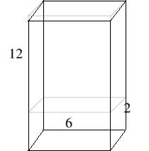
20

- If the minute hand moves half way around a clock, how many degrees has the minute hand turned?

  - 90º

  - 180º
  - 270º
  - 360º

- If you are facing north and you turn your body so that you are facing east, how many degrees have you turned?

  - 90º

  - 180º

  - 270º

  - 360º

- Find the sum of 23.5 + 157.93. Show your work.

_______________

70. Which of the following angles is an acute angle?
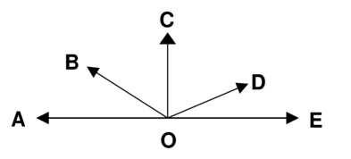

- <BOE

- <AOD
- <BOC

- <COE

21

71. Which of these angles is a straight angle?
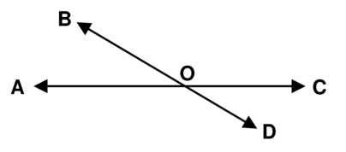

  - <AOD
  - <AOC

  - <AOD

  - <COD

- Which pair of angles are vertical angles?

  - <AOD and <BOC

  - <AOB and <BOC

  - <BOC and <COD

  - <AOC and <BOD

- Which of these angles is a vertical angle to <DOC?

  - <AOB

  - <BOC

  - <AOD

  - <DOA

- What is the measure of angle y? (Do NOT use a protractor to find your answer.)
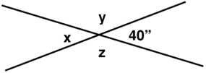

- 40

- 50

- 140

- 180

22

- In the diagram below, which is the closest to the angle measurement? (Do NOT use a protractor to find your answer.)

  - 25 degrees

  - 85 degrees

  - 150 degrees
  - 180 degrees

- A pizza is divided into 6 pieces. Each piece is the same size, as shown in the picture. Think about what the total angle measurement is for all 6 pieces. Then calculate the angle measurement for one piece, angle x.

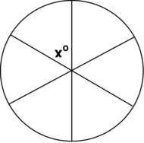

One piece of pizza has an angle measure of

  - 30 º
  - 40 º
  - 50 º
  - 60 º

- A gate is open in a 50 degree angle. How many more degrees will the gate have to open until it is flat against the fence?

  - 40 º
  - 100 º
  - 130 º
  - 310 º
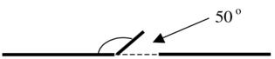
23

78. Solve the following:
1 x 9 = ______ | 3 x 6 =________ | 9 x 7 =_______ | 6 x 2 =_______
8 x 6 =______ | 2 x 2 =________ | 3 x 8 =_______ | 9 x 9 =_______
24 ÷ 3 = ______ | 7 x 7 = ________ | 56 ÷ 7 = ______ | 4 x 0=_______
48 ÷ 6 = ______ | 18 ÷ 6 =_______ | 7 x 3 =_______ | 7 x 6 =_______

79. In a spinner game, the spinner has 4 regions of unequal size, as shown below.
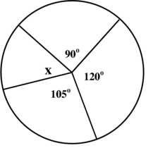

How many degrees are in the missing angle x? (Do NOT use a protractor.)

  - 30º
  - 45º
  - 60º
  - 75º

- Raymond played with a game spinner shown below and realized that he could see angles in different sections of the spinner.
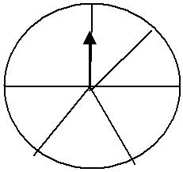

What is the sum of all these angles?
- 90º
- 185º
- 275º
- 360º

24

81. <ACD measures 60º. Find the measurement of <ACB. (Do NOT use a protractor.)
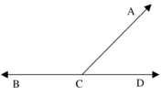

  - 120º

  - 130º

  - 160º
  - 180º

- Which of the following could be the measures of the interior angles of a triangle?

  - 30º, 30º, 30º

  - 30º, 60º, 90º

  - 60º, 90º, 120º

  - 60º, 120º, 180º

- This is a parallelogram. In all parallelograms, the opposite angles are equal. Find the measure of angle x.
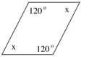

  - 50º

  - 60º

  - 70º
  - 120º

- What is the measurement of angle A?
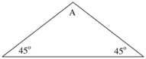

  - 45º

  - 60º
  - 90º
  - 120º

25

- What is the sum of the angles in this polygon? Choose the correct answer, and then explain how you figured it out.
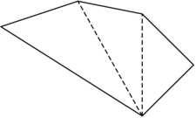

  - 180º

  - 360º

  - 540º
  - 720º

- In a quadrilateral, two of the angles each have a measure of 110º, and the measure of the third angle is 90º. What is the measure of the remaining angle?

  - 50º

  - 90º
  - 130º
  - 160º

- In this triangle, what is the measure of angle B?

  - 30º

  - 45º
  - 60º
  - 180º

- What is the measurement of angle X in this triangle?

  - 90º

  - 120º
  - 130º
  - 135º
26

- If angle A equals 45º, what is the measure of angle B? Choose the correct answer, then explain who you figured it out.
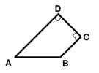

  - 60º

  - 130º

  - 135º
  - 145º

- How many more magazines were sold in 1990 than in 1989?
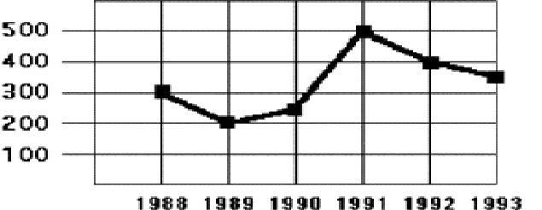

  - About 50 magazines

  - About 100 magazines

  - About 200 magazines

  - About 250 magazines

- Using the graph below, when did New Zealand’s GDP increase the most?
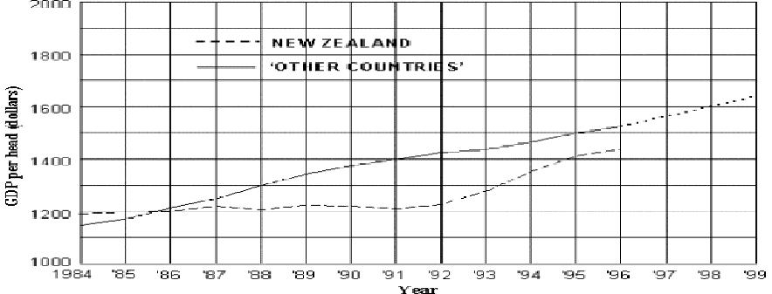

Gross Domestic Product (GDP) for New Zealand and Other Countries

- 1986-87
- 1988-89

- 1992-93

- 1995-96

27

- Using the graph above. In 1988 what was the difference of the GDP for Other Countries and New Zealand?

  - About $100 per head

  - About $200 per head

  - About $1200 per head
  - About $1300 per head

- Family A has 2 children, Family B has 1 child, Family C has 1 child, and Family D has 4 children. What is the mean number of children for the families?

  - 1
  - 2

  - 3

  - 4

- The set of data below represents the number of books read in one month by each member of the book club.

3, 6, 7, 3, 3, 9, 0, 0, 1, 3, 7, 2, 5, 9, 7 What is the mode number of books for this set of data?

    - 0

    - 3

    - 7

    - 9

What is the range number of books for the set of data above?

  - 0

  - 1

  - 7

  - 9

- The data below show a set of Angela’s golf scores. What is the mean of the scores listed?

84, 88, 88, 77, 73

  - 73

  - 82

  - 84

  - 88

- Family A has 2 children, Family B has 0 children, Family C has 1 child, and Family D has 0 children. Find the mode for this data.

  - 0

  - 1

  - 2

  - 3

28

97. Find the difference:
701 |  | 68 | 100 | 63 | 35 | 114 | 66
- 35 |  | - 27 | - 37 | - 47 | -15 | - 37 | - 24
98. Find the product:
36.1 |  | 0.47 | 5.9 | 0.28 | 19 | 5.6 | 78
x 3.7 |  | x 68 | x 39 | x 1.8 | x 4.7 | x 3.6 | x .37

99. Last summer Samantha swam the backstroke in five swim meets. Her times were: 56 seconds 56 seconds 44 seconds 47 seconds 42 seconds

Find the mean of her times.

    - 47

    - 49

    - 50

    - 56

- Mary’s quiz scores were 92, 85, 78, 92, 71, 77, and 80. She told her mother she had an average of 92 for her quiz scores. Which term best describes her average score?

    - Mean

    - Median

    - Mode

    - Range

- What is the mean of this set of numbers? 4, 8, 3, 2, 5, 8, 12

    - 4

    - 5

    - 6

    - 7

- What is the median of this set of numbers? 4, 8, 3, 2, 5, 8, 12

    - 6

    - 8

    - 5

    - 4

  - What is the mode of this set of numbers? 8, 1, 3, 10, 8, 1, 2, 5, 6, 1, 88

________________

29

104. Students collected books for a book drive. Five students collected the following number of books:

Student 1: 17 books Student 2: 8 books Student 3: 10 books Student 4: 8 books Student 5: 12 books

What is the mode of this set of data? __________________

What is the mean number of books collected per student?

  - 8 books

  - 10 books

  - 11 books

  - 12 books

- The mean of nine test scores is 61. If a score of 71 is added to the group of scores, what is the new mean?

  - 62

  - 65

  - 66

  - 68

- What is the difference between the mean salary of the workers and the mean salary of everyone including the President and Vice-President? You may use a calculator.

Position |  | Salary
President |  | $256,000
Vice-President |  | $127,000
Worker #1 |  | $ 35,000
Worker #2 |  | $ 20,000
Worker #3 |  | $ 18,000
Worker #4 |  | $ 31,000
Worker #5 |  | $ 24,000
Worker #6 |  | $ 21,000
Worker #7 |  | $26,000
A. $25,000
B. | $37,000
C. | $45,000
D. | $62,000

30

107. | The table shows the scores of 20 students on a history test. What is the average student
score? You may use a calculator.
Score | Number of Students
90 | 3
85 | 5
80 | 3
75 | 4
70 | 2
60 | 0
55 | 3

  - 26

  - 74

  - 77

  - 85

- Sandy had test scores of 20, 25, 17, 22 and 21 (out of 25 total). What is her average (mean) score?

____________________________

On the next 3 tests Sandy’s scores were 24, 24 and 23. What is her mean now?

- 24

- 23

- 22

- 21

Explain how you figured this out.

______________________________________________________________________________

______________________________________________________________________________

- Philip solved the following problem incorrectly. Explain his mistake. 1659

x 21 1659
+3318
4977

______________________________________________________________________________

110. Use mental math to solve:

A. 400 x 3 = ___________ 60 x 60 = __________ 8,000 x 20 = ___________

B. 1600 ÷ 80 = _________ 250 ÷ 50 = _________ 12000 ÷ 400 = _________

31

111. | Find the product:
36 | 47 | 59 | 28 | 19 | 56 | 78
x 47 | x 68 | x 39 | x 18 | x 47 | x 36 | x 37

- Construct a factor tree for the composite number 27. Express your answer in exponential notation (powers).

- Nancy and Gabe had a pizza with 12 pieces. Brent ate 1/3 of a pizza and Kayla ate ¼ of a pizza. How much of the whole pizza is left? Show your work.

___________________

114. Show which is larger, smaller or equal using the less than symbol (<), the greater than symbol (>), or the equal sign (=).

1 in.³______ 1 ft.³

1 cm.³_____ 1 m.³

  - ft.³______ 1 yd.³

- Explain why the formula for finding the area of a triangle makes sense in terms of the area of a rectangle (use a drawing in your explanation).

32

116. Use a protractor to measure the following angles. Then classify them as acute, obtuse, or right angles.

<DOE =_________ This angle is ___________ (acute, obtuse or right?)

<COD =_________ This angle is ___________ (acute, obtuse or right?)

<BOE =_________ This angle is ___________ (acute, obtuse or right?)

<AOC =_________ This angle is ___________ (acute, obtuse or right?)

117. This parallelogram has one angle of 50º. What are the measures of the other angles?
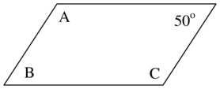

  - Measure of angle A _______

  - Measure of angle B ________

  - Measure of angle C ________

- Show your work: 723.89 + 23.8 = ___________

- Show your work: 824.03 – 123.8 = __________

- Show your work: 4.3 x 6.8 = ____________

33

121. Do the following divisions. Then check your answer. Show your work. No calculators! Check your work:

A. 1524 ÷ 6 =________

x 6 1524

B. 380 ÷ 10 = _________

x 10 380

C. 4235 ÷ 10 = _________
x____________

_____

D. 4) 769

x_____________

_____

E. 5) 765

x_____________

34

122. Find the products or quotient.

Any multiplication problem you do not know quickly please practice on flash cards.

4 | 5 | 3 | 5 | 9 | 5 | 7 | 9 | 5 | 11 | 6 | 9 | 7 | 7
x7 | x0 | x3 | x8 | x4 | x7 | x1 | x5 | x6 | x5 | x6 | x8 | x7 | x9

__ | ___ | ___ | ___ | ___ | ___ | ___ | ___ | ___ | ___ | ___ | ___ | ___
2)16 | 3)3 | 3)15 | 5)20 | 3)18 | 3)6 | 5)15 | 7)56 | 9)27 | 4)16 | 7)21 | 4)20 | 7)28

6 | 4 | 7 | 5 | 12 | 3 | 6 | 3 | 0 | 7 | 5 | 6 | 3 | 8
x2 | x4 | x6 | x4 | x12 | x5 | x3 | x8 | x8 | x3 | x5 | x4 | x9 | x4

72 ÷ 8 = ______ 8 ÷ 2 =_______ 72 ÷ 9 = ______ 6 ÷ 1 =_______

__ | ___ | ___ | ___ | ___ | ___ | ___ | ___ | ___ | ___ | ___ | ___ | ___
8)16 | 3)21 | 9)18 | 4)24 | 2)6 | 1)8 | 5)35 | 7)35 | 3)27 | 6)36 | 3)24 | 2)0 | 4)32

6 | 8 | 4 | 4 | 1 | 8 | 11 | 6 | 7 | 5 | 2 | 6 | 4 | 11
X9 | x8 | x9 | x3 | x4 | x3 | x7 | x5 | x8 | x3 | x7 | x8 | x5 | x4

123. Convert from fraction, decimal and percentage.

Fraction (simplest form) | Decimal | Percentage
½ | .08 | 20%
____________ | _________ | __
____________ | __________ | ____ _ _

35

Answer the following in simplest form. Show your work.

- ½ + ¾ = ___________

- 2 2/5 + 1 2/3 = ___________

- 2/8 – 1/5 = _________

CONGRATULATIONS!!! You have completed the summer math packet. You are now ready for 6th grade success! Please turn this packet into you 6th grade teacher, the first week of school.

