1

Summer Math Reinforcement Packet
Students Entering into 1st Grade

Our kindergarteners had a busy year learning new math skills. Mastery of all these skills is extremely important in order to develop a solid math foundation. The first grade math program will add onto these kindergarten skills, so any time spent learning or reinforcing these concepts will be very beneficial for your child. Each year builds upon the previous year’s skills in math. Any areas your child has difficulty you may want to give them additional practice.

Student mastery of the basic math skills is as important to success in future mathematical procedures and reasoning as learning the alphabet is to reading and writing.

Have your child complete one page (one side)- two times a week of the math packet. Please return this completed packet to your first grade teacher.

After your child has completed the math problems and you feel your child is still struggling on a certain concept and needs further practice, you can have your child play games on some of the web sites listed on the next page, play games or make up additional problems of your own for additional practice.

Also included is an answer key on the reverse side for parents use only in assisting your child.

Enjoy your summer!!

2

KINDERGARTEN

GRADE LEVEL EXPECTATIONS IN MATHMATICS

When entering first grade this is what your child should already know.

- Read and write the numbers up to 30. Can count objects up to 30.
- Orally can count to 100. Can count by 5’s and 10’s to 100.
- Orally can count to 30 by 2’s.

4. Can use the phrase “more than”, “same as”, and “less than” when comparing 2 numbers from 1 – 30.

Example: 19 is less than 20. 21 is more than 20.
- Add and subtract numbers from 1 to 10. Can write 2 + 5 = 7 and 7 – 2 =5.

- Know and use common words for the parts of the day and relative time. Example: morning, afternoon, evening, yesterday, tomorrow, last week, next year.

- Identify tools that tell time. Clocks measure hours and minutes, calendars measure days, weeks and months.

- Identify daily landmark times to the nearest hour. Example: breakfast is 8 o’clock in the morning, lunchtime is 12 o’clock, and bedtime is 8 o’c lock in the evening.

- Compare two or more objects by length or weight. Which is shorter, longer, taller, smaller, lighter, or heavier?

- Familiar with three-dimensional objects. Ball/sphere, box/cube, soup can/cylinder, ice cream cone/cone.

- Identify, sort and classify objects. Sort items by color, size, shape, etc.

12. Can continue a pattern of 3 to 4 different objects. For example: XXoZZXXoZZxx_______. Red Blue Yellow Red Blue Yellow Red Blue___.

13. Know the different coin values: dime = 10 cents, nickel = 5 cents, penny = 1 cent.

3

Excellent websites for fun learning and reinforcement of math skills:

www.harcourtshcool.com Click the red box, select math, select HSPMath, select Michigan, click on the “K” ball or “1” ball for a challenge. Select a game. Identify 11-30, Count Along to 100, and E-Lab Number Patterns are very good.

www.aplusmath.com go under “Flashcards” or ”Game Room” on the left side of the screen. They can practice adding and subtracting.

www.mathisfun.com Select Numbers then scroll down the page and select “Ordering Numbers” or
“Counting” or “Skip Counting” Back at home screen select |  | games and pick a game to play.
www.eduplace.com | Select your state – “Michigan” press submit. Select the student tab then click on
the “mathematics” rectangle. Click in the center book “Hou |  | ghton Mifflin Math 2007”. Click on “Grade
K”. Select any games. Extra Help is very good, also math lingo.

www.illuminations.nctm.org Select activities then select grade level. Click on Search.

www.internet4classrooms.com Click on first picture “Grade Level Help for Kindergarten thru 8th grade” Then click on “Kindergarten Skill Builders” in center, then click on “Interactive Mathematics Skill Builders” it’s the second picture. Select any game.

www.aaamath.com At the top pick “Kindergarten” or “First Grade” for a challenge. Choose any of the activities then select “play” option.

www.funbrain.com Lots of fun games to choose from.

Other games and activities you can play:

- Have them write their numbers in sidewalk chalk.

- Number Dot to Dot books.

- Write the numbers 1 – 50 or to 100 on index cards or pieces o f paper. One number on each card.

- You can play war. Divide cards up evening among all players. Cards are face down.

Each player turns over their top card. Highest number takes all the cards. Keep playing until you are through all cards. Person with the most cards wins.

- Have all cards face down. Select 3 cards and put them in order from least to greatest or you can do largest to smallest.
- Pick an object. Have them find another object that is lighter, heavier, smaller, taller or longer

- Use colorful cereal or buttons. You start a pattern and have them finish it. For example you pick a red piece of cereal then yellow, green, red, yellow and have them select the next color. You can use anything in the kitchen to sort by color or shapes. Use different cereal or cracker shapes. You start a pattern and have them select the next couple pieces.

- When receiving change at a store. Hand your child a coin and ask them it’s name and value. OR Hide a few different coins around the room. Have them go find the quarters. Or find coin that is worth 10 cents.

- Take a deck of cards and remove the face cards (kings, queens, jacks). All aces are one. Divide the cards evenly among 2 or 3 players. Each player will turn over 2 cards. Using those 2 cards each player needs to make the smallest number and then read the number made. For example you have a 5 and 2 card. You can make the number 25, and they have to say the number. Player with the smallest number takes all the cards. Player with the most cards wins. You can play a largest number version game also.

4

Entering First Grade Summer Math Packet

First Name: _________________Last Name:____________________

First Grade Teacher: ________________________

I have checked the work completed:___________________________________________

Parent signature

1. Fill in the missing numbers:
1 |  | 3 |  | 5 | 6 |  |  | 9 | 10
 |  | 13 | 14 |  | 16 |  | 18 | 19
 | 22 |  |  | 25 |  | 27 |  |  | 30

- Skip count by 2’s: 2, 4, ____, _____, _____, _____, _____, ____.

- Skip count by 5’s: 5, 10, _____, _____, _____, _____, _____.

- Fill in the missing numbers:

_________, 11, ________ ________, 9, ________

8, 9, ________ 10, ________, 12

________, 10, ________ ________, 6, ________

5

5. Circle which one has more?

6. Circle which one has less?

7. List the value of each coin.

________ _______ ______ ________
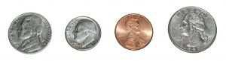

8. Fill in the blanks, skip count by 10’s.

10 |  |  |  |  | 60 |  |  |  | 100

6

- Write these numbers from smallest to largest: 13, 16, 23, 7.

  - 13, 23, 16, 7

  - 16, 13, 23, 7

  - 7, 13, 21, 23

- Color in the Last 5 Pictures:

- Color in the First 7 Pictures:

- Color in the Middle 5 Pictures:

- Find the sum.
3 3
+ =
7

14.
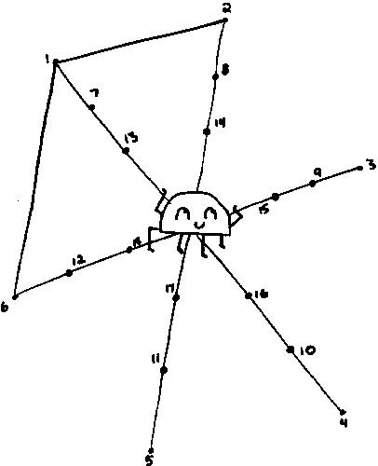

- Find the sum.

8 |  |  |  |  |  |  |  |  |  |  |  |  |  |  |  |  |  |  |  |  |  |  |  |  |  |  |  | 5
 |  |  |  |  |  |  |  |  |  |  |  |  |  |  |  |  |  |  |  |  |  |  |  |  | + |  |  | =
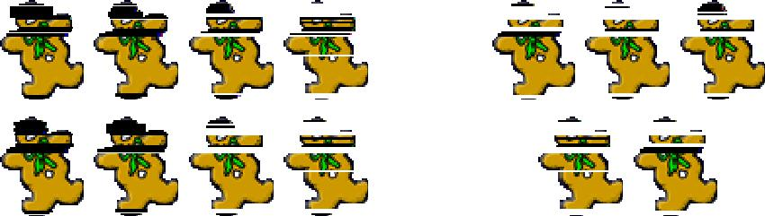
8

- Find the sum.

8 |  |  |  |  |  |  |  |  |  |  | 8
+ |  |  |  |  |  |  |  |  |  |  | =

- Draw the hands on the clock.

9:00
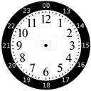

- Count to 50 to someone else in your family.

- Draw the hands on the clock.

4:00
9

- Fill in the missing numbers:

1 |  | 3 |  | 5 | 6 |  |  | 9 | 10
11 |  | 13 | 14 |  | 16 |  | 18 | 19
 | 22 |  | 24 | 25 |  | 27 |  |  | 30
31 |  |  | 34 | 35 |  | 37 |  | 39
 | 42 | 43 |  | 45 | 46 |  | 48 |  | 50
51 | 52 |  | 54 |  | 56 |  |  | 59
 | 62 | 63 | 64 |  | 66 | 67 | 68 |  | 70
 |  | 73 |  | 75 |  | 77 | 78 |  | 80
81 | 82 |  | 84 | 85 | 86 | 87 |  | 89
 | 92 |  | 94 |  | 96 |  | 98 | 99

- Look at the chart you completed in number 13. Now count by 5’s and color those numbers orange.

- If today is Sunday what day is yesterday? Circle one

Saturday Monday Tuesday

10

- Draw a line to match the coin with its name:

Back of penny
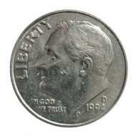

Back of nickel
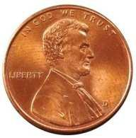

Front of dime
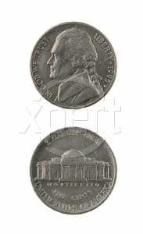

Front of nickel
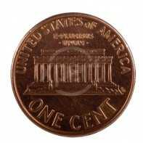

Front of penny

Select the one best answer for each question.

- Which number is ONE MORE than 13?

  - 12

  - 14
  - 23

11

- Which number is ONE LESS than 8?

  - 6

  - 7

  - 9

- Circle the group of stars has more stars in it?

- Look at the chart in number 13. Count by 2’s and color those numbers yellow.

- Fill in the blanks, count by 5’s. You can refer to #13.

5 |  | 15 |  |  | 30
55 |  |  |  |  | 80 |  |  | 95 | 100

- What part of the day do you come to school in 1st grade?

  - Morning

  - Afternoon

  - Evening

12

- What part of the day do you go to bed?

  - Morning

  - Afternoon

  - Evening

- Which tool would you use for telling time?

  - Ruler

  - Scale

  - Clock

- What does a clock show you?

  - What day it is such as Monday or Wednesday

  - What month it is such as January or May

  - What time it is such as 9:30 or 3:00

- Who is taller: a kindergartener or a teacher?

  - Kindergartener

  - Teacher

- Fill in the blanks

11, 12,_____, 14, 15, _____, 17, ______

- 1 dime is equal to:

  - 1 cent

  - 5 cents
  - 10 cents

13

- Write these numbers from smallest to largest. 6, 12, 2, 15

_____, _____, _____, _____

- How much money is this?
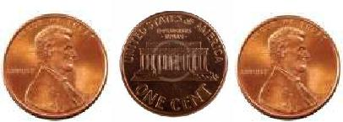

  - 3 cents

  - 15 cents
  - 30 cents

- Circle the rectangle?

- What part of the day comes after lunch?

  - Morning
  - Afternoon

  - Evening

- While holding a clock, the teacher says, “What is this object?” What is it used for?

  - Clock, for telling time.

  - Calendar, for finding the date.
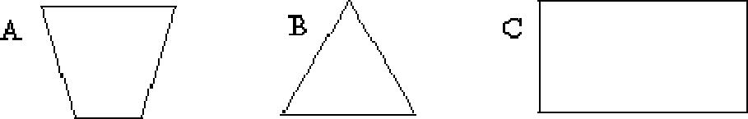
14

- Which object is not like the others? How is it different?

  - The rectangle is different because it has two long sides.

  - The triangle is different because it has three sides.
  - The parallelogram is different because it has slanted sides.
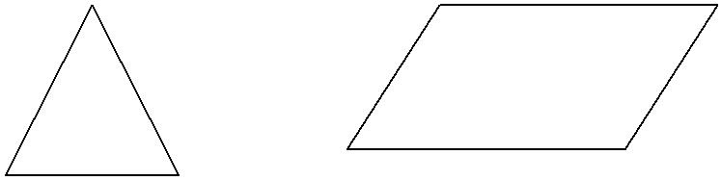

42.
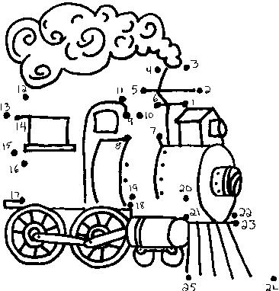
15

43. Place an X on the geometric shape does not belong in this group?
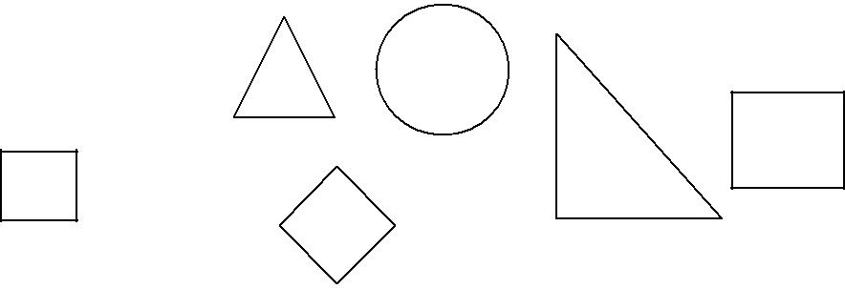

- What shape is the tool below?

  - A square

  - A rectangle
  - A triangle

- What shape would most likely be a refrigerator?

  - Sphere

  - Cone
  - Prism
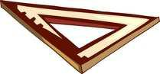

46.
3 2

+ =
16

47. Show this pattern in another way by coloring the squares.
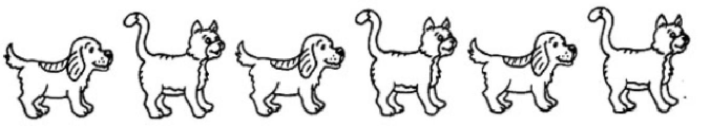

48. Circle the picture that comes next in the pattern.
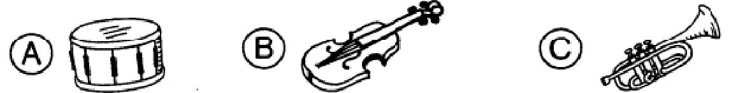

  - If today is Wednesday, tomorrow is

    - Tuesday
    - Thursday

    - Friday

- If today is Tuesday, yesterday is

    - Sunday

    - Monday
    - Wednesday

17

- Circle the item that is heavier

  - Kleenex Box

  - Telephone Book

- Circle the item that is lighter

  - Paper Clip

  - Can of Soup

- What is the shape of a penny or dime?

  - A circle
  - A square

  - An oval

- Which shape comes next in this pattern?
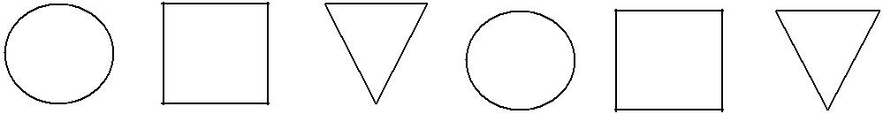
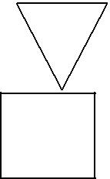

A. | Triangle
B. | Square
C. | Circle
18

55. Count by 10’s
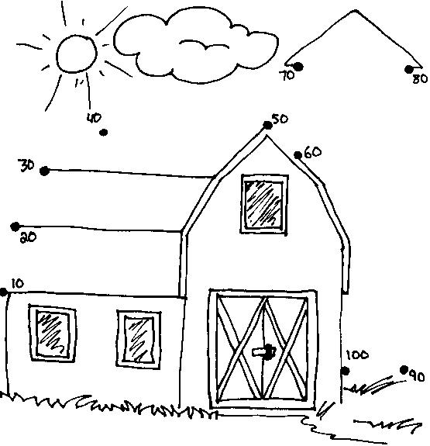

- What is longer a kitchen table or a pencil? Circle one

  - Kitchen table

  - Pencil

19

57. Fill in the missing numbers:

1 | 2 |  | 4 |  |  | 7 |  | 9 | 10
 | 12 | 13 |  |  | 16 |  | 18 |  | 20
 | 22 |  | 24 | 25 |  | 27 |  |  | 30
31 |  |  | 34 |  |  | 37 |  | 39
 | 42 |  |  | 45 | 46 |  | 48 |  | 50
51 | 52 |  | 54 |  | 56 |  |  | 59
 | 62 | 63 |  | 65 | 66 |  | 68 | 69 | 70
71 |  | 73 |  | 75 |  | 77 | 78 |  | 80
81 | 82 |  | 84 |  | 86 | 87 |  | 89
 | 92 |  | 94 |  | 96 |  | 98 | 99 | 100

58. Mrs. Clor buys 9 ice creams and gave away 3 so

________ are left. Cross out the ones given away.
20

59. Mrs. DeCarlo buys 7 lollipops and drops 2. How many does she have left? Cross out the ones dropped.

________ lollipops left

60. Circle the larger number of the two.
9 | 7 | 11 | 8 | 60 | 59
19 | 31 | 17 | 21 | 13 | 11
41 | 39 | 35 | 45 | 28 | 31
44 | 30 | 20 | 19 | 14 | 24

21

- Draw a line from the number to the number word.

1 | seven
2 | three
3 | one
4 | nine
5 | two
6 | ten
7 | eight
8 | six
9 | five
10 | four

22

62. Connect the dots 1 to 65.
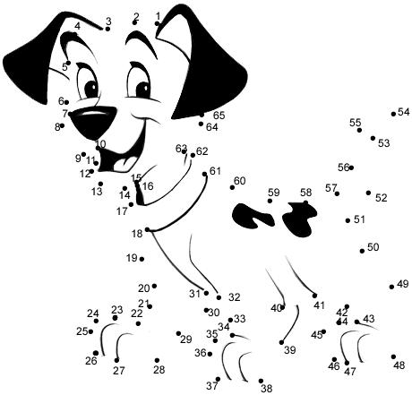
23

- Fill in the blanks.

Before | After | Between
_______ 15 | 8 _______ | 9 ______ 11
_______ 20 | 29 ______ | 14 _____ 16
_______23 | 17 ______ | 12 _____ 14

- If yesterday is Sunday, today is ___________.

  - Saturday

  - Monday

- If tomorrow is Friday, today is ____________.

  - Thursday

  - Saturday

Congratulations!! You have completed the summer math packet. Turn this into your 1st grade teacher.

