1

Summer Math Reinforcement Packet
Students Entering into 2nd Grade

Our first graders had a busy year learning new math skills. Mastery of all these skills is extremely important in order to develop a solid math foundation. The second grade math program will add onto these first grade skills, so any time spent learning or reinforcing these concepts will be very beneficial for your child. Each year builds upon the previous year’s skills in math. Any areas your child has difficulty you may want to give them additional practice.

Student mastery of the basic math skills is as important to success in future mathematical procedures and reasoning as learning the alphabet is to reading and writing.

Have your child complete one page (one side), three times a week of the math packet. Please return this completed packet to your second grade teacher.

After your child has completed the math problems and you feel your child is still struggling on a certain concept and needs further practice, you can have your child play games on some of the web sites listed on the next page, play games or make up additional problems of your own for additional practice.

Also included is an answer key on different color paper for parents use only in assisting your child.

Enjoy your summer!!

2

FIRST GRADE

GRADE LEVEL EXPECTATIONS IN MATHEMATICS

When entering second grade this is what is expected that your child should already know.

- Read and write the numbers up to 110 by 1’s, 2’s, 5’s, 10’s. Also by starting with various numbers.

- Comparing numbers up to 110 using such phrases as “same as”, “more than”, “greater than”, “fewer than”. Ex. 70 is one more than ___ (69). Also can put a set of numbers from least/smallest to greatest/largest.

- Can state one more than, one less than, 10 more than, 10 less than, for any number given (up to 100).

- Count backwards from any number between 0 and 100.

- List addition facts for 2 through 10. Ex. 8 = 2 + 6 = 3 + 5 = 4 + 4.

- Understanding the reverse relationship between adding and subtracting. Ex. If 8 + 3 = 11 then 11 – 3 = 8 and 11 – 8 = 3.

- Knows answer to addition facts up to 10 + 10 and can state the answer within 2 – 4 seconds.

- Knows all subtraction facts up to 10 – 9 and can state the answer within 2 – 4 seconds.

- Can solve problems like ____ + 2 = 7 and 10 - ____ = 6.

- Can measure objects with a ruler to the closest inch. Also can compare 2 or more objects using the words shorter, shortest, longer, longest, taller, tallest.

- Tell time using a standard face clock by the hour and half hour.

- Identify coins by name and value. Ex. Penny = 1 cent, quarter = 25 cents.
- Count coins up to $1.00.

- Solve story problems using addition or subtraction of length, money and time.

- Can describe where an object is located using such words as above, below, behind and in front of. Ex. Sally is in front of Bob.

- Can continue a pattern using number, shape or size.

3

Excellent websites for fun learning and reinforcement of math skills:

www.wildmath.com Select “Play the game”. Select addition or subtraction and grade. You can race to beat your time.

www.harcourtschool.com Click the red box, select math, select HSPMath, select Michigan, click on the “1” ball or “2” ball for a challenge. Select a game. A ddition Surprise, Addition Bricks, E-lab Number Patterns are very good.

www.aplusmath.com go under “Flashcards” or “Game Room” on the left side of the screen. They can practice adding and subtracting.

www.mathisfun.com Select Money then select Money Master, click on the US flag, select simple. Or you can select numbers then Math Trainer for adding and subtracting. Back at home screen select games and pick a game to play.

www.eduplace.com Select your state – “Michigan” press submit. Selec t the student tab then click on the “mathematics” rectangle. Click in the center book “Hou ghton Mifflin Math 2007”. Click on “Grade 1”. Select any games. Extra Help and Extra Practice i s good, also eGames.

www.illuminations.nctm.org Select activities then select grade level. Click on Search.

www.aaamath.com At the top pick “First” or “Second” for a challenge. Choo adding or subtracting then select “play” option toward the t op of the screen. countdown games are good ones.

se any of the activities like 20 Questions and

www.funbrain.com Lots of fun games to choose from.

Other games and activities you can play:

- Number Dot to Dot books or coloring books with addition/subtraction problems to color by.

- Write the numbers 1 – 50 or to 100 on index cards or pieces o f paper. One number on each card. You can play war. Divide cards up evening among all players. Cards are face down. Each player turns over their top card. Highest number takes all the cards. Keep playing until you are through all cards. Person with the most cards wins. Have all cards face down. Select 4 to 5 cards and put them in order from least to greatest or you can do largest to smallest.

- Using sidewalk chalk, have them write the numbers counting backwards from 20.

- Play a game while in the car or waiting in line.

What number comes before 60? 50 is one more than ____? (49) What comes between 62 and 64?

What number comes after 29? 39 is one less than____? (40)

- Practice counting by 5’s, 10’s, or 2’s. Have them write i t in sidewalk chalk. Counting by 2’s how many steps are from your bedroom to the bathroom? Etc..

- Take a deck of cards and remove the face cards (kings, queens, jacks). Aces are one. Divide the cards evenly among 2 players. Each player flips over a card. The first one to add the 2 numbers correctly wins the cards. After going through the pile of cards, the player with the most cards wins. You can do a subtraction version also.

4

Entering Second Grade Summer Math Packet

First Name: __________________ Last Name:__________________

Second Grade Teacher: ________________________

I have checked the work completed________________________________________

Parent signature

1. Fill in the missing numbers:

1 |  | 3 |  | 5 | 6 |  |  | 9 | 10
11 |  |  | 14 |  | 16 |  | 18 | 19
 | 22 |  | 24 | 25 |  | 27 |  |  | 30
31 |  |  | 34 | 35 |  | 37 |  |  | 40
 | 42 | 43 |  | 45 | 46 |  | 48 |  | 50
51 | 52 |  | 54 |  | 56 |  |  | 59
61 |  | 63 |  |  |  | 67 | 68 |  | 70
 |  | 73 |  | 75 |  | 77 |  | 79
 | 82 |  |  |  | 86 | 87 |  | 89
 | 92 |  | 94 |  | 96 |  | 98

- Skip count by 2’s: 2, 4, ____, _____, _____, _____, _____, ____.

- Skip count by 5’s: 5, 10, _____, _____, _____, _____, _____.

5

 | 4. Find the sum:
5 | 8 | 1 | 2 | 2 | 7 | 5
+3 | +0 | +2 | +2 | +6 | +3 | +5

7 | 5 | 3 | 2 | 5 | 2 | 3
+7 | +2 | +0 | +7 | +1 | +5 | +3

1 | 4 | 0 | 1 | 9 | 1 | 1
+7 | +5 | +6 | +9 | +9 | +4 | +8

5. List the value of each coin.

________ _______ ______ ________
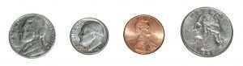

6. Fill in the blanks, skip count by 5’s.

 | 10 |  |  |  |  | 35
55 |  |  |  |  | 80 |  |  |  | 100

- Write these numbers from smallest to largest: 21, 16, 35, 8.

  - 21, 35, 16, 8
  - 16, 21, 35, 8

  - 8, 16, 21, 35

6

8. Draw a line to match the coin with its name:

Front of penny
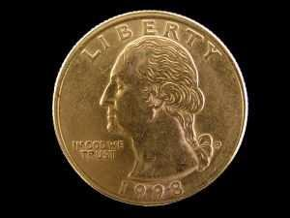

Back of nickel
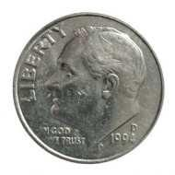

Front of quarter
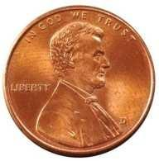

Front of dime
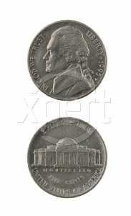

Back of quarter
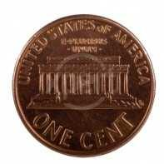

Front of nickel
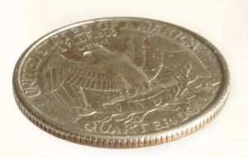

Back of penny

7

 | 9. Find the sum.
6 | 8 | 4 | 2 | 5 | 1 | 4
+6 | +1 | +3 | +3 | +0 | +6 | +4

Select the one best answer for each question.

- Which number is ONE MORE than 27?

  - 26
  - 28

  - 37

- What number is represented by the following?
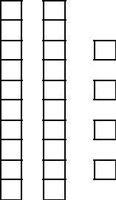

  - 24
  - 42

  - 60

- How can you make 8 cubes?

  - 2 cubes plus 5 cubes
  - 1 cube plus 8 cubes

  - 2 cubes plus 6 cubes

8

- Sally and Ron are coming over at 2 o’clock to play and they have to go home at 5 o’clock. How many hours can you play together?

  - 2 hours
  - 3 hours

  - 5 hours

- Which number fact makes 8?

  - 7 + 2

  - 3 + 4

  - 4 + 4

- Which of these groups of stars has more stars in it?

  - Group A

  - Group B

- Amanda looked at the night sky. She saw 12 stars. Then she saw 7 more. What number sentence shows how she counted the total number of stars she saw?

  - 12 – 7 = 5

  - 12 + 7 = 5

  - 12 + 7 = 19

9

- Write the missing numbers. Skip count by 2. 8, ____, ____, ____, 16 22, ____, ____, ____, 30

54, 56, ____, ____, ____, 64

- Amanda had 12 crayons. Then Paul gave her 7 more. Make a drawing to show how you would solve this problem. Then circle

your answer.

  - 5

  - 12
  - 19

- Since 3 + 6 = 9, then which subtraction is also correct?

  - 3 – 6 = 9

  - 6 – 3 = 9
  - 9 – 3 = 6

- Solve this problem using a drawing:

8 birds were sitting in a tree. 3 flew away. How many are left?

__________ birds are left.

- Find the difference.

8 | 7 | 6 | 9 | 8 | 9 | 6
- 2 | - 0 | - 1 | - 4 | - 6 | - 2 | - 3

10
- What is the unknown number in __?___ + 2 = 7?

  - 9

  - 7

  - 5

- Write the missing numbers. Skip count by 5’s. 25, _____, _____, _____, 45 50, _____, _____, _____, 70 35, _____, _____, _____, 55 75, _____, _____, _____, 95

- What is the unknown number in 10 - __?__ = 6?

  - 4
  - 6

  - 16

- Add 22 + 5 without using a calculator or fingers.

  - 25
  - 27

  - 29

- Find the difference.

8 | 7 | 6 | 5 | 6 | 7 | 8
- 5 | - 2 | - 3 | - 4 | - 2 | - 4 | - 4

11

- The movie starts at 3:00 pm and ends at 6:00 pm, how long is the movie?

  - 2 hours

  - 3 hours
  - 4 hours

- Write in the missing numbers. Skip count by 10’s.

25, _____, _____, _____, _____

- Find the sum:

6 | 0 | 3 | 3 | 6 | 8 | 1
+2 | +4 | +1 | +9 | +8 | +7 | +3

9 | 8 | 7 | 9 | 8 | 6 | 7
+3 | +8 | +4 | +4 | +3 | +4 | +6

- Melissa had 22 stones. Her mother gave her 30 more stones. How many did she have altogether? Do not use a calculator.

  - 25

  - 32
  - 52

- Subtract 16 – 6 without using a calculator.

  - 12

  - 10
  - 6

12

- Look at the clock and tell what time it is.

  - 4:06

  - 4:30
  - 6:20

- What time is it?
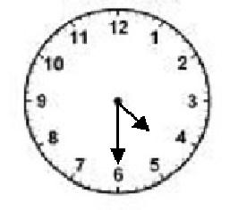
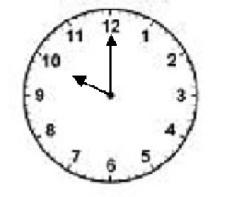

  - 2 o’clock
  - 10 o’clock

  - 12 o’clock

- This number line shows only the number 8. Write the number 6 where it is supposed to be.

8

35. Fill in the blanks. Skip count by 5’s. 25, _____, _____, _____, _____, 50 60, _____, _____, _____, 80 80, _____, _____, _____, 100

13

- Which clock reads 2:30?
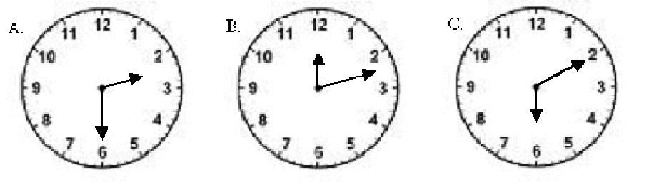

  - A

  - B
  - C

- What time is it?
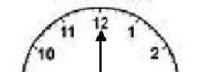

  - 12:00

  - 12:30
  - 6:00

- Find the difference:
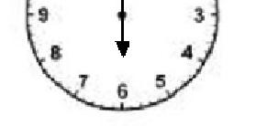
5 | 11 | 2 | 12 | 11 | 9 | 12
- 0 | - 9 | - 2 | - 5 | - 6 | - 9 | - 6

10 | 13 | 7 | 15 | 13 | 10 | 15
- 9 | - 7 | - 3 | - 9 | - 4 | - 8 | - 6

14

Ask Mom or Dad for some coins to help with the following questions or draw the coins on paper.

- Mike had 2 quarters in his pocket. He traded his 2 quarters with his friend Pam. They made an even trade. Mike got:

  - 25 pennies

  - 6 nickels
  - 5 dimes

- 10 dimes are equal to:

  - 2 quarters

  - $1.00
  - 10 cents

- 1 dime is equal to:

  - 1 nickel

  - 3 nickels
  - 1 nickel and 5 pennies

- How much money is this?
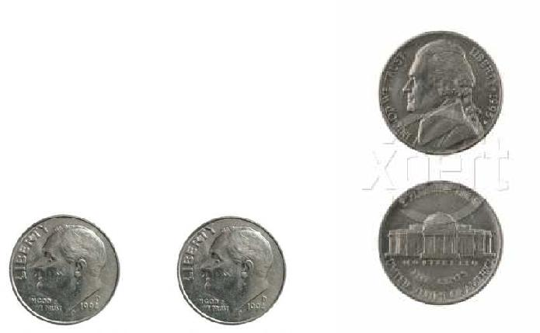

- 30 cents

- 35 cents

- 40 cents

15

- Write these numbers from smallest to largest. 36, 12, 28, 7

_____, _____, _____, _____

- How much money is this?

  - 5 cents
  - 28 cents

  - 53 cents

- 23 is one more than ______

- _____ is just before 12.

- Jack had 50 cents. He lost 2 dimes. How much money does he have left?

  - 48 cents

  - 30 cents
  - 20 cents

- I bought candy for 20 cents and gum for 15 cents. How much money did I spend?

  - 5 cents
  - 35 cents

  - 30 cents
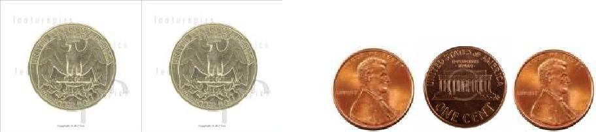
16

- Jane found 3 dimes and 1 nickel in her pocket. How much money did she have?

  - 4 cents

  - 30 cents
  - 35 cents

- Find the sum.

8 | 5 | 9 | 2 | 4 | 8 | 5
+9 | +8 | +6 | +8 | +9 | +8 | +9

3 | 6 | 4 | 1 | 7 | 7 | 5
+5 | +1 | +2 | +1 | +1 | +2 | +4

- 16 is just after _______

- ______ is between 44 and 46.

- _____ is one more than 18.

- Fine the difference.

11 | 17 | 11 | 3 | 18 | 12 | 9
- 7 | - 8 | - 3 | - 2 | - 9 | - 3 | - 1

3 | 16 | 9 | 9 | 15 | 5 | 6
- 1 | - 7 | - 4 | - 2 | - 7 | - 1 | - 5

17

- Art class start at 10:00 and ends at 12:00. How long is art class?
  - 1 hour

  - 2 hours

  - 3 hours

- John had 15 cents. He bought candy for 10 cents. How much money does he have left?

  - 5 cents
  - 10 cents

  - 25 cents

- ____ is just before 22.

- 17 is one less than _____.

- Stop signs have the shape of an octagon. How many sides do these signs have?

  - 6 sides
  - 8 sides

  - 12 sides

- Find the sum or difference.

4 | 7 | 3 | 8 | 3 | 0 | 7
+6 | - 5 | +8 | - 6 | +2 | +2 | +8
9 | 4 | 7 | 5 | 2 | 6 | 9
- 9 | +7 | +9 | +7 | +4 | +9 | - 5
15 | 7 | 13 | 6 | 3 | 16 | 9
- 9 | +7 | - 9 | +6 | +3 | - 9 | - 5

18

- What shape is the tool below?

    - a square
  - a rectangle

  - a triangle

- Which shape is the rectangle?

- 19 is just after ______

- _____ is just before 29.

- What is the shape of a penny or dime?

  - A circle

  - A square

  - An oval

- Draw a square. How many sides does a square have?

  - Three

  - Four
  - Five
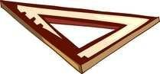
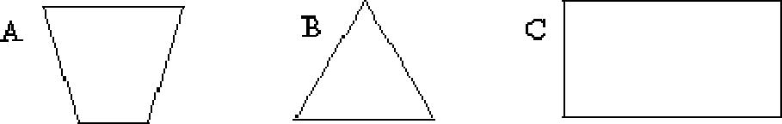
19
- Look at where the star and moon are located. Then choose which is correct.

  - The moon is BEHIND the star.

  - The moon is BELOW the star. C. The moon is ABOVE the star.

- Find the sum or difference.
4 | 15 | 5 | 4 | 8 | 6 | 3
-2 | - 2 | +5 | -3 | + 4 | + 5 | + 7

5 | 9 | 4 | 8 | 6 | 8 | 2
+ 6 | + 7 | + 8 | - 7 | - 4 | - 1 | + 9

69. Look at where the cat and toys are located. Then choose which is correct.

- The toys are to the right of the cat.

- The toys are to the left of the cat.

- The toys are above the cat.

20

- Which number is 1 less than 38?

  - 37

  - 38

  - 39

- _______ is between 45 and 47.

- Count by 2’s. 10, ____, _____, ______, _____, _____

- 19 is one less than ______.

- Jim likes to draw. He made a pattern. What would come next in his pattern?

- What is just before 40? _________

- Count by 2’s. 6, 8, _____, _____, _____, _____, 18, _____.

- What number is ten more than 37?

  - 36

  - 38
  - 47
21
- Write in the missing numbers. Skip count by 5’s. 15, _____, ______, _____, _____, 40

- Find the difference.

17 | 4 | 14 | 7 | 13 | 8 | 11
- 9 | - 4 | - 6 | - 6 | - 8 | - 4 | - 2

80. Mrs. Clor has 15 star stickers. Kate has 1 fewer clown stickers. How many clown stickers does Kate have?

____________ clown stickers

- Count backwards, write in the missing numbers.

20, 19, ____, _____, _____, _____, _____, ______, 12

82. Brent’s favorite number is the one that comes just before 25. What is his favorite number?

______ is his favorite number.

- Write in the missing numbers. Skip count by 3’s.

3, 6, ____, _____, _____, _____, _____, _____, 27

- Find the difference.
12 | 8 | 6 | 3 | 9 | 10 | 9
- 8 | - 8 | - 2 | - 0 | - 6 | - 6 | - 5

9 | 8 | 10 | 9 | 10 | 1 | 12
- 7 | - 3 | - 7 | - 3 | - 5 | - 1 | -4

7 | 13 | 4 | 5 | 16 | 12 | 8
- 1 | - 6 | - 1 | - 2 | - 8 | - 7 | - 2

22

85. Look at the pictograph. What hair color did most children in Mrs. Moss’ class have?

Hair Color in Mrs. Moss' Class
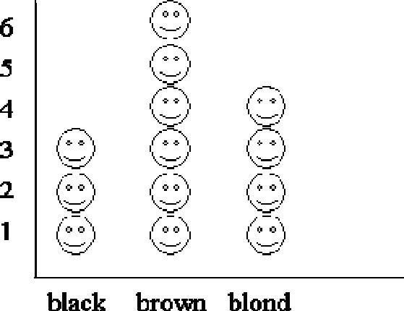

  - black

  - brown

  - blond

- Write > or <

9 | 7 | 9 |  | 5 | 36 | 29
19 | 31 | 11 |  | 23 | 48 | 11
41 | 39 | 25 |  | 32 | 23 | 31
44 | 30 | 49 |  | 39 | 19 | 24

- How much does 3 dimes equal? __________

- How much does 3 nickels equal? __________

23

- What number is one more than 63? ________

- Look at the pictograph. How many children in Mrs. Moss’ class have black hair?

Hair Color in Mrs. Moss' Class
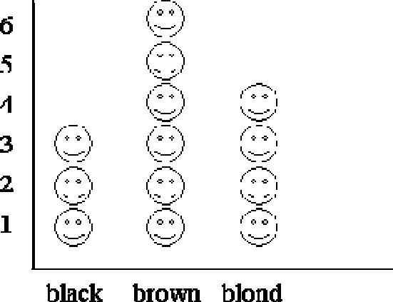

  - 3

  - 4
  - 6

- Find the sum or difference. Watch the signs.

8 |  | 5 | 6 | 14 | 8 | 9 | 6
+8 |  | - 3 | +6 | - 8 | - 6 | +9 | - 3

6 | 6 | 3 | 3 | 7 | 7 | 2
+6 | - 4 | +3 | +9 | - 4 | +7 | +2

7 | 8 | 13 | 4 | 10 | 11 | 6
-5 | +8 | - 5 | +4 | - 1 | - 4 | - 4

24

- 36 is one more than _______

- _____ is just before 40.

- _____ is one more than 28.

- _____ is just after 22.

- Find the sum or difference. Watch the signs.

4 | 10 | 14 | 8 | 8 | 11 | 7
+6 | - 4 | - 5 | +6 | - 1 | - 2 | +8

9 | 4 | 16 | 5 | 2 | 13 | 8
+9 | - 2 | - 9 | +7 | +4 | - 9 | - 5

- What number is just after 29? _______

- _______ is just before 40.

- This number line shows only the number 5. Write the number 6 where it is supposed to be.

- What number is 1 less than 56?
________

25

- Show how you can make 24 using tens and ones. You can make a drawing of counters or ten blocks.

- Write 5 different number facts that equal 9 such as 2 + 7. 1.__________________

2.__________________

3.__________________

4.__________________

5.__________________

- Find the sum:

8 | 6 | 4 | 7 | 2 | 3 | 9
+8 | +6 | +4 | +7 | +2 | +3 | +9

- Show how you would solve this problem:

Steven had 7 toy cars. He wanted 13. How many more toy cars would Steven need to have 13 altogether?

Then choose 2 math sentences that could show how to solve this.

- 7 + 6 = 13

- 13 – 7 = 6

- 7 + 13 = 20
- 7 – 13 = 6

26

- Find the sum or difference:

4 | 15 | 5 | 4 | 8 | 6 | 3
- 2 | - 2 | +5 | -3 | + 4 | + 5 | + 7

5 | 9 | 4 | 8 | 6 | 8 | 2
+ 6 | + 7 | + 8 | - 7 | - 4 | - 1 | + 9

- Finish the pattern.

0, 2, 4, 6, 8, ____, ____, ____

  - 9, 10, 11

  - 10, 12, 13

  - 10, 12, 14

- Add 3 + 5 + 2. Write your answer here ______.

- If 7 + 4 = 11, then what other subtraction problem would also be true?

  - 7 – 4 = 11

  - 11 – 4 = 7

  - 4 – 7 = 11

- If 14 – 6 = 8, then what other addition problem wou ld also be

true?

  - 14 + 8 = 6
  - 6 + 14 = 8

  - 8 + 6 = 14

27

110. Brent had 9 dollars. After Brent got paid 7 dollars for mowing a lawn, how much did he have?

 | __________ dollars
111. | Numbers… they are shady characters. You have to keep an

eye on them! In the grid below, a secret message is hidden from your view. If you shade in all the “shady” odd numbers, you will be able to decode the message!

 | 18 | 3 | 16 | 14 | 16 | 48 | 24 | 88 | 46 | 72 |  | 92
 | 5 | 2 | 17 | 28 | 30 | 98 | 5 | 50 | 86 | 90 |  | 47
 | 13 | 20 | 23 | 4 | 24 | 52 | 3 | 20 | 10 | 66 |  | 13
 | 9 | 32 | 27 | 40 | 6 | 100 | 39 | 54 | 30 | 56 |  | 1
 | 7 | 22 | 11 | 12 | 97 | 33 | 43 | 44 | 73 | 81 |  | 65
 | 25 | 34 | 29 | 42 | 95 | 8 | 35 | 60 | 15 | 58 |  | 89
 | 21 | 38 | 19 | 10 | 93 | 62 | 37 | 402 | 397 | 60 |  | 87
 | 36 | 15 | 46 | 44 | 99 | 29 | 41 | 40 | 401 | 77 |  | 143
Congratulations!! You have completed the summer math packet. Turn this into your 2nd grade teacher.

