1

Summer Math Reinforcement Packet
Students Entering into 3rd Grade

Our second graders had a busy year learning new math skills. Mastery of all these skills is extremely important in order to develop a solid math foundation. The third grade math program will add onto these second grade skills, so any time spent learning or reinforcing these concepts will be very beneficial for your child. Each year builds upon the previous year’s skills in math. Any areas your child has difficulty you may want to give them additional practice.

Student mastery of the basic math skills is as important to success in future mathematical procedures and reasoning as learning the alphabet is to reading and writing.

Have your child complete one page (one side), three times a week of the math packet. Please return this completed packet to your third grade teacher.

After your child has completed the math problems and you feel your child is still struggling on a certain concept and needs further practice, you can have your child play games on some of the web sites listed on the next page, play games or make up additional problems of your own for additional practice.

Also included is an answer key on different color paper for parents use only in assisting your child.

Enjoy your summer!!

Reminder - Practicing addition facts and subtraction facts (up to 18 - 9) are VERY important!

2

SECOND GRADE

GRADE LEVEL EXPECTATIONS IN MATHMATICS

When entering third grade this is what is expected that your child should already know.

- Count, read and write numbers up to 1000 in words and numerals, by 1’s, 10’s and 100’s.
- Can order numbers from largest to smallest or smallest to largest up to 1000.

- Can count by 3’s up to 36 and by 4’s up to 48.

- Can count by 2’s, 5’s, and 10’s starting at any number. Ex. Starting with 35 and count by 5’s.
- Fluently adding and subtracting 2 numbers through 99.

- Find distance between numbers on a number line. Ex. How far is 79 from 26?

- Be able to find the missing number. Ex. 42 + ____ = 57; use the relationship between addition and subtraction to determine the missing number 57 – 42 = ____.

- Understand multiplication as repeated addition or counting the total number of objects. Example: 3 x 5 = 5 + 5+ 5 = 15, 3 x 5 is 3 groups of 5 objects.

- Multiplying numbers up to 5 x 5.
- Understanding division as another way of expressing multiplication using fact families.

Example: 2 x 3 = 6 can be rewritten as 6 ÷ 2 = 3 or 6 ÷ 3 = 2.

- Name and write commonly used fractions ½, 1/3, 2/3, ¼, 2/4, ¾.

- Place 0 and halves on a number line or a ruler. ½, 1 ½, 2 ½

- Can order fractions by size using the denominator up to 1/12. Ex. ½ > 1/12; 1/6 < 1/3

- Tell and write time from a traditional clock face in 5 minute intervals using both AM and PM. Interpret time both as minutes after the hour and minutes before the next hour.

- Use the concept of duration of time. Ex. What time will it be half an hour from 10:15?

- Can read and write amounts of money using decimals. $1.15 or $0.25

- Add and subtract money in mixed units. Ex. $2.50 – 60 cents and $5.75 - $3.

- Understand perimeter is adding the length of all the sides.

- Solve simple word problems using length and money.

- Identify, describe and compare shapes such as triangles, rectangles, squares, circles, semi-circles, spheres and rectangular prisms.

- Recognize that shapes that have been slid, turned, or flipped are the same shape. Ex. A square rotated ¼ turn is still a square.

- Read and interpret pictographs with scales or 2 and 3. Ex. Each pizza slice represents 2 kids liking pizza. Or each bat represents 3 kids liking baseball.

3

Excellent websites for fun learning and reinforcement of math skills:

www.wildmath.com Select “Play the game”. Select addition or subtraction and grade. You can race to beat your time.

www.harcourtschool.com Click the red box, select math, select HSPMath, select Michigan, click on the “2” ball or “3” ball for a challenge. Select a game.

www.aplusmath.com Go under “Flashcards” or “Game Room” on the left side o f the screen. They can practice adding and subtracting. Very important to know the addition facts and subtraction facts from memorization or within a couple seconds.

www.mathisfun.com Select Money then select Money Master, click on the US flag, select simple. Or you can select numbers then Math Trainer for adding and subtracting. At the home screen select games and pick a game to play.

www.eduplace.com Select your state – “Michigan” press submit. Select the student tab then click on the “mathematics” rectangle. Click in the center book “Houghton Mifflin Math 2007”, Click on “Grade 2”. Select any games. Extra Help and Extra Practice is good, also eGames.

www.illuminations.nctm.org Select activities then select grade level. Click on Search.

www.aaamath.com At the top pick “Second” or “Third” for a challenge. Choose any of the activities like adding or subtracting then select “play” option toward the top of the screen. 20 Questions and countdown games are a good ones.

www.funbrain.com Lots of fun games to choose from.

Other games and activities you can play:

- Take a deck of cards and remove the face cards (kings, queens, jacks). Aces are one. Divide the cards evenly among the players. Keep cards face down in a pile. Each player turns over 3 cards and tries to make their largest number they can with their 3 cards. Everyone must read their number and the one with the largest number collects all the cards. The player with the most cards at the end of the game is the winner. You can play smallest card version to change it up.

- Using sidewalk chalk, have them count by 3’s or 4’s.

- Play a game while in the car or waiting in line.

What number comes before 260? 750 is one more than ____? (749)

What number comes after 529? 339 is one less than____? (340)

- Practice counting by 5’s, 10’s, or 2’s. When standing in line or driving in a car you give them a number and have them count by 5’s or 10’s from that number. Ex. Start with 35 and count by 10’s. Start with 55 and count by 5’s.

- Take a deck of cards and remove the face cards (kings, queens, jacks). Aces are one. Divide the cards evenly among 2 players. Each player flips over a card. The first one to add the 2 numbers correctly wins the cards. After going through the pile of cards, the player with the most cards wins. You can do a subtraction version also. With subtraction you can change one of the cards to add a 10 to it. For example you have the cards 4 and 2. You can add ten to any one of card to make it 12 – 4, or 14 – 2.

- Play store and practice counting change. Give allowances in change and have them count it.

4

Entering Third Grade Summer Math Packet

First Name: __________________ Last Name:___________________

Third Grade Teacher: ________________________

I have checked the work completed________________________________________

Parent signature

Multiple Choice Questions:
Select the one best answer for each question.

- One day at lunch Tony used straws to show his friend 3 ways to make 24. Some straws were bundled in groups of ten. Which picture does NOT show a right way?

- Which is a correct addition pair for 100?

  - 91 + 5
  - 97 + 4
  - 92 + 8

- Brent and Kayla each caught 1 fish.

    - Brent’s fish was 48 inches long.

    - Kayla’s fish was 22 inches longer than Brent’s fish.

Which number sentence can be used to determine the length of Kayla’s fish?

- 12 + 10 = ?

- 48 – 22 = ?
- 48 + 22 = ?

5

- Which is a correct addition pair for 100?

  - 45 + 55
  - 30 + 60
  - 64 + 46

- Find the sum:

5 | 8 | 1 | 2 | 2 | 7 | 5
+3 | +0 | +2 | +2 | +6 | +3 | +5

7 | 5 | 3 | 2 | 5 | 2 | 3
+7 | +2 | +0 | +7 | +1 | +5 | +3

 | 6. Find the difference:
15 | 14 | 13 | 16 | 17 | 12 | 17
- 7 | - 5 | - 6 | - 9 | - 9 | - 4 | - 8

11 | 10 | 12 | 12 | 11 | 13 | 14
- 6 | - 1 | - 3 | - 5 | - 8 | - 5 | - 6

7. List the value of each coin.

________ _______ ______ ________
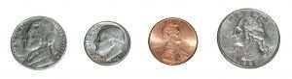
6

8. Count the coins from someone in your house. Ask for their permission first. Draw the coins out if needed. (Up to $2.00)

___________

- Which is NOT a correct addition pair for 100?

  - 98 + 2
  - 87 + 23
  - 66 + 34

10. Find the distance between 31 and 44 on a number line?

- 12
- 13
- 16

11. How far is it on the number line from 54 to 68?

  - 13

  - 14
  - 15

- David wanted 100 trading cards. He has 55 cards. How many more cards does he need?

  - 35

  - 45
  - 155

7

13. Tammy wanted 100 trading cards. She had 55 cards. Which number sentence could Tammy use to help her figure out how many more cards she needs?

- 100 + _____ = 55
- 55 + ____ = 100
- 100 + 55 = _____

14. Find the missing value in this number sentence: 13 + ____ = 68.

  - 37
  - 45
  - 55

- To find the missing value in this number sentence 29 + _____ = 88, you should-

  - start with 29 and add 88.
  - start with 29 and subtract 88.
  - start with 88 and subtract 29.

- 54 birds were sitting in a tree. Some flew off. Then there were 30 left. How many birds flew off?

  - 14
  - 24
  - 30

- There are 19 marbles in all. How many are under my hand?
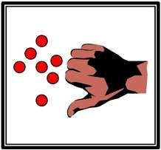

- 12

- 17
- 24

8

18. Farmer Tom had 39 cows in a pasture. During a storm, the fence broke and 13 of the cows wandered off. Which number sentence can be used to find out how many cows stayed in the pasture?

  - 39 + 13 =
  - 39 – 13 =
  - 13 + 13 + 13 + 13 =

- Mary saved $5.60 in a week. The next week she saved $1.20. How much money did she save altogether?

  - $4.30
  - $5.80
  - $6.80

- Mary saved $56 in a week. The next week she saved $12. How much money did she save altogether?

  - $43
  - $58

  - $68

21. There were 63 pumpkins in a pumpkin patch. Wanda picked 19 of the pumpkins. How many of the pumpkins were left in the patch?

  - 82
  - 56
  - 44

- The Wildcats scored 63 points in the game. But they only scored 27 points in the first half. How many points did the Wildcats score in the second half?

  - 26

  - 36
  - 44

9

- At the basketball game, the Wildcats beat the Bears 63 to 56. How many points did both teams score all together?

  - 103
  - 109
  - 119

- Find the sum or difference: Watch the signs!

8 | 7 | 6 | 9 | 3 | 9 | 6
- 2 | +9 | +6 | +8 | +6 | - 2 | +3

6 | 8 | 13 | 3 | 6 | 18 | 5
+7 | +4 | - 7 | +9 | +8 | - 7 | +3

19 | 18 | 17 | 9 | 8 | 6 | 7
- 3 | - 8 | - 4 | +4 | - 3 | +4 | +6

14 | 7 | 13 | 8 | 3 | 8 | 17
- 6 | +5 | - 8 | +6 | +2 | +2 | - 8

- Find the difference: Remember “bottom bigger better
borrow” For example: 52 – 16, the 2 is bigger than |  |  |  |  | the 6, so you need
to borrow from the 5 (tens).
28 | 34 | 47 | 75 | 64 | 41 | 69
- 9 | - 7 | -19 | -37 | -14 | - 9 | - 5

10

- There were 654 geese on a pond when another flock of 135 geese arrived. How many geese were on the pond then?

  - 789
  - 799
  - 889

- The sum of 587 and 221 is closest to

  - 400
  - 800
  - 900

- The sum of 313 and 406 is closest to

  - 100
  - 700
  - 800

- Estimate the sum of these two numbers: 167 + 122 =

  - 200
  - 250
  - 300

- Jim wants 500 trading cards. He has 50 cards. How many more cards does he need? (Do this in your head, without pencil and paper or calculator.)

  - 400
  - 450
  - 550

- Write the number six hundred seven______________

- Write the number one hundred twelve____________

- Write the number two hundred eight____________

11

- 357 – 100 is

  - 356
  - 347
  - 257

- It took Jon a month to save $5.00. How many months will he have to save money to buy a $25.00 skateboard?

  - 2
  - 5
  - 20

- Baliee has 12 Yugi-Oh cards. She wants to share them equally with 3 friends. Which number sentence shows this situation?

    - 12 - 3 = 9

    - 12 ÷ 3 = 9
    - 12 ÷ 3 = 4

- Which of these pictures shows 3 times 5 (3 x 5)?
A

B

C

42. Find the difference then check your answer by adding.

48 | then
- 19
 |  | +19
 | 48
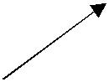
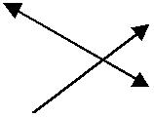

12

43. Elisa arranged her checkers in a pattern shown below.

o o o o o o o o o o o o o o o o o o o o

Which operation best shows how she arranged them?

A. 4 x 5
  - 4 + 5
  - 5 x 5

- Karen has 2 bowls of cereal each day. After 5 days, how many bowls of cereal has she eaten? Show this with a drawing and write it out with numbers and symbols, then solve it.

Drawing:

Written with numbers and symbols:

Find the answer:
  - 10
  - 7
  - 3

- Farmer Jill had 3 chickens that laid eggs. Each day they laid 2 eggs each. Which sentence shows how many eggs she got each day?

  - 3 – 2 = 1

  - 3 + 2 = 5
  - 3 x 2 = 6

13

- Each pack of gum has five sticks. How many sticks are in three packs of gum? Draw a picture or use objects to show this situation, then find the answer.

  - 5
  - 8
  - 15

- There are six juice boxes in a pack. How many packs are needed for 18 students? Draw a picture or use objects to show this situation.

  - 3
  - 5
  - 15

- Find the sum or difference:

25 | 46 | 26 | 58 | 69 | 39 | 73
+11 | + 29 | +37 | +15 | +26 | +89 | +17

10 | 13 | 7 | 15 | 13 | 10 | 15
- 9 | - 7 | - 3 | - 9 | - 4 | - 8 | - 6

41 | 67 | 41 | 73 | 38 | 42 | 59
- 7 | - 28 | -23 | - 42 | - 8 | -13 | -21

49. Fill in the blanks, skip count by 5’s.

25, _____, _____, _____, _____

50, _____, _____, _____, _____

14

- Tina is having a birthday party. She has invited 20 friends. Each of her tables seats four people. How many tables does she need?

  - 4
  - 5
  - 6

- What addition problem shows the multiplication 5 x 2?

  - 5 + 5
  - 2 + 2
  - 5 + 2

- A whole pizza had 4 equal pieces. David ate 1 piece. Draw the whole pizza and shade the part David ate.

What fraction of the pizza did David eat?

A. ½
  - ¼
  - ¾

- You divide a chocolate bar into 3 equal pieces. You give your friend 1 of these pieces. What fraction of the candy bar did you give to your friend?

Draw a picture:

- 1/2

- 1/3
- 2/3

15

- This picture shows which fraction?

  - 2/2
  - 2/4
  - 4/4

- Bob wanted to share his candy bar with his friend Mark. He offered Mark the following choices:
A. You can have 1/10 of my candy bar.
B. You can have 1/6 of my candy bar.

C. You can have 1/2 of my candy bar.

Mark wants to choose the biggest piece. Tell which fraction Mark should choose and tell why.

  - A
  - B
  - C

- A pan of brownies is cut into twelfths (1/12). Each of the 10 students in the speech class ate one brownie. How many were left for the teacher?

Draw a picture:

  - 1

  - 2
  - 3

- Joe’s jump rope is 3 feet long. Sally’s jump rope is 5 feet long. How much longer is Sally’s jump rope?

  - 2 feet

  - 6 feet
  - 8 feet

16

- Shawn used a triangular chip shaped like the one below to find the area of this rectangle. How many triangles will fit into the rectangle? (You may trace the triangle and use the tracing to measure.)

  - 3 triangles
  - 6 triangles
  - 8 triangles

- A second grade square table measures 3 feet on each of the four sides. What is the measurement of its perimeter?

  - 6 feet

  - 9 feet
  - 12 feet

- What is the area of the rectangle below?
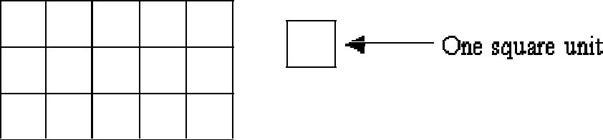

  - 8 square units

  - 15 square units

  - 16 square units

- Write seven hundred eight_________________

- Write eight hundred eighty-eight___________

17

- Find the area of this rectangle.

  - 2 square units

  - 3 square units
  - 6 square units

- Tell the time indicated on the clock pictured below.
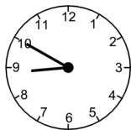

  - 10 minutes to nine
  - 10 minutes to eight
  - Nine – ten

- What time is it on this clock?
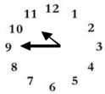

  - 11:45

  - 10:45
  - 9:10

- Write four hundred ten_________________

- Write six hundred six__________________

18

68. What time will it be half hour after the time shown on the clock?
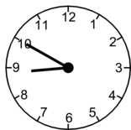

    - Eight-twenty
    - Nine–ten
    - Nine-twenty

- School is over at 3:15. It is a half-hour bus ride home. What time will you arrive home from school?

    - 3:30
    - 3:45

    - 4:45

  - Find the difference:

17 | 4 | 14 | 7 | 13 | 8 | 7
- 9 | - 4 | - 6 | - 6 | - 8 | - 4 | - 2

12 | 8 | 6 | 3 | 9 | 10 | 9
- 8 | - 8 | - 2 | - 0 | - 6 | - 6 | - 5

- Johnny bought a notebook for $6.50. He paid for it with a $10.00 bill. How much change should he have received?

  - $4.50
  - $3.50

  - $2.50

19

72. | Find the sum:
39 | 48 | 17 | 69 | 65 | 24 | 66
+27 | +33 | + 7 | +23 | +35 | +27 | +21

- My piggy bank has 3 quarters. How much money do I have?

  - $0.75
  - $7.50
  - $75

- What is the total value of this money?

  - $1.25
  - $3.25
  - $32.5

- Juan had $1.50. He was given 60 cents more. How much money does Juan have?

  - $1.56
  - $2.10
  - $61.50

- Jenn had $4.30. She lost 40 cents. How much money does Jenn have now?

  - $0.30

  - $3.90
  - $4.70

20

- Dominick has $2.05. He gets two dollars for his allowance. How much money will Dominick have?

  - $2.00
  - $4.00
  - $4.05

- Kate has $2.00. Her mom gave her 75 cents. How much money does she have now?

  - $1.25
  - $2.75
  - $77.00

- Tamara has $12.97. She spends $8 on a new doll. How much money does she have left?

  - $4.00
  - $4.97

  - $8.97

- Two tables are pushed together to make more room for a big dinner. One table is 5 feet long and the other table is 6 feet long. How long are the two tables together?

  - 9 feet
  - 11 feet
  - 56 feet

- Write in words 403________________________________________________

- Write in words 340_______________________________________________

- Write in words 701_______________________________________________

- Write six hundred forty-one___________

21

- Mom would like new pink nail polish. It costs $1.19. She asks you to count the change in her wallet. You find:
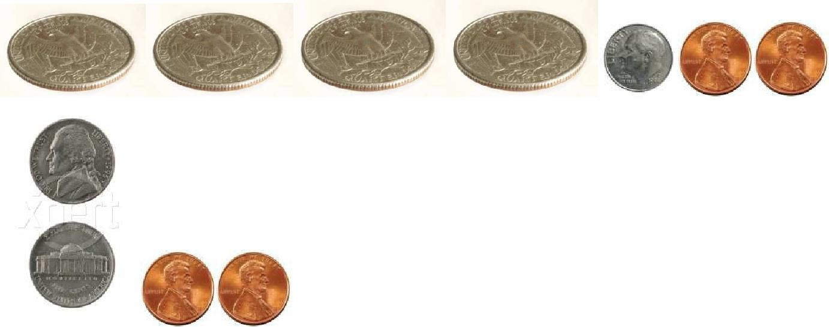

You report to mom:

A. There is not enough money to buy the nail polish.
  - There is exactly enough money to buy the nail polish.
  - There is more than enough money to buy the nail polish.

- Find the sum or difference.

28 | 45 | 66 | 74 | 56 | 39 | 60
+38 | - 13 | +26 | -38 | -27 | +29 | -23

47 | 46 | 33 | 43 | 70 | 71 | 42
+27 | - 24 | +33 | +59 | - 46 | - 27 | +29

57 | 28 | 53 | 42 | 70 | 61 | 66
-25 | +48 | - 25 | +44 | -21 | -24 | -34

22

- Joe draws a shape that has 3 sides and 3 angles. What shape did he draw?

  - Triangle
  - Circle
  - Square

- What do all squares have?

  - 4 unequal sides
  - 4 equal sides
  - 6 equal sides

- Joe draws a shape that has 3 sides and 3 corners. What shape did he draw?

  - Square
  - Circle
  - Triangle

- What shape is this?

  - Semicircle
  - Sphere
  - Circle

- Which of the following would have a curved surface?

  - Cardboard box

  - Soup can
  - Stop sign

- What shape has a curved surface?
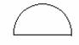
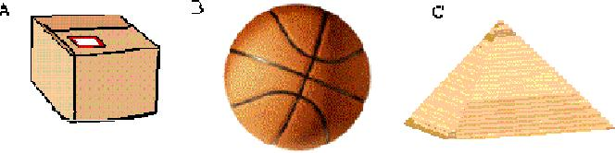
23

93. Which of these has six sides?
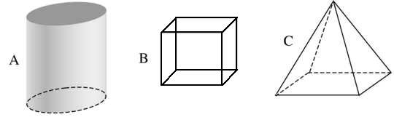

- On this map, each side of a square is one block. Matt started at (C, 1), the School. He went up 2 blocks and right 1 block. Where is he now?
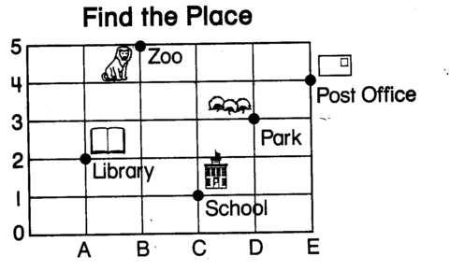

  - Post Office
  - Park
  - Library

- Find the sum:

8 | 6 | 4 | 7 | 2 | 3 | 9
+8 | +6 | +4 | +7 | +2 | +3 | +9

5 | 10 | 12 | 14 | 11 | 13
+5 | +10 | +12 | +14 | +11 | +13

24

96. What place is located at (B, 5)?

  - Post Office
  - Library
  - Zoo

- Where is the bunny located?
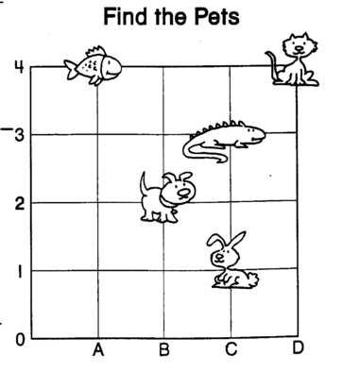

  - (B, 2)

  - (C, 1)
  - (C, 3)

- What place value is the underline digit? 647

  - Hundreds

  - Tens

  - Ones

25

99. Where is the turtle located?
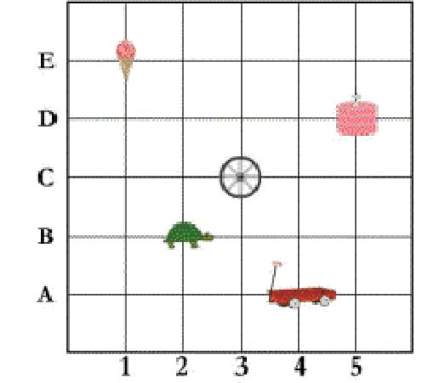

  - (3, B)
  - (2, C)
  - (2, B)

- Use this graph about Pizza Day for the following questions.

Each stands for 3 slices.

Matt
Sue
Tom

How many pieces of pizza did Matt eat?

- 4

- 9
- 12

26

101. Use this graph about Pizza Day for the following question.

Each stands for 3 slices.

Matt
Sue
Tom

How many more slices of pizza does Tom have than Sue?
  - 3
  - 2
  - 1

- Which appears to be the location of the point marked on the number line?

0 1 2 3 4

  - 1

  - ½

  - 1 ½

- What location is the X marked on the number line below?

X

0 1 2 3 4

- 1 ½

- 2 ½

- 3 ½

27

104. Use the graph about Pizza Day for the following question.

Each stands for 3 slices.
Matt
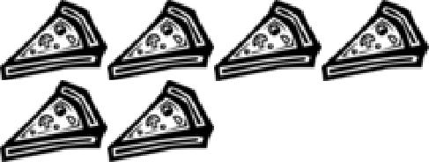
Sue

Tom

How many slices of pizza do Matt and Tom have together?

  - 7
  - 15
  - 21

- Find the sum or difference:

29 | 17 | 58 | 32 | 17 | 51 | 44
+23 | +18 | -24 | +22 | +43 | -27 | +17
74 | 45 | 88 | 72 | 54 | 33 | 54
-26 | - 15 | +18 | - 37 | +34 | +33 | - 18

106. Complete these number patterns.

3, 6, 9, _____, _____, _____, _____, _____, _____

4, 8, 12, _____, _____, _____, _____, _____, _____

45, 50, _____, _____, _____, _____

28

- Fill in the numbers to complete each pattern:

  - 813, 814, 815, ______, ______, _______

  - 240, ______, 260, 270, ______

  - 300, 400, ______, ______, 700, ______

- Each picture in this graph stands for 2 pieces of fruit.

PEARS

APPLES
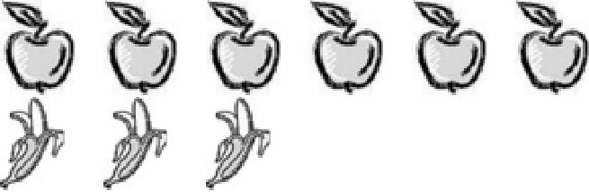

BANANAS

How many apples are there altogether?
  - 6
  - 8
  - 12

- Write the number sixty-three:____________

Write the number forty-five:___________

Write the number eighty-nine:_________

Write the number twenty-seven:_________

- Use < or > to show which number is larger. 78 _____ 98 250_______112 105_______ 150 122_______222

29

111. Each picture in this graph stands for 2 pieces of fruit.

PEARS

APPLES

BANANAS

How many more pears are there than bananas?
  - 1
  - 2
  - 7

- Complete these number patterns: 25, 30, 35,____, ______, ______

9, 12, 15, ____, ______, ______

130, 140, 150, _______, _______, _______

- Sam is making 5 apple pies. He uses 4 apples in each pie. How many apples will Sam use altogether? Draw a picture to show this.

Picture:

Answer:__________________

30

- Maria is going to open a lemonade stand. It takes 5 lemons to make a pitcher of lemonade. How many lemons will she need to make 5 pitchers of lemonade?

Draw a picture:

Answer:_________ lemons
115. Place an X where this number should go on the number line:

- Two students were arguing about fractions. Pat said that 6/6 is more than 3/3. Chris said they are equal. Who do you agree with?

  - Pat
  - Chris

Draw a picture to explain your answer.

117. Draw hands on this clock face to show 20 minutes after 8
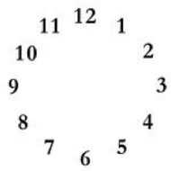
31

- My piggy bank has 3 quarters, 3 dimes, 3 nickels, and 7 pennies. Write the amount of the quarters, dimes, nickels, and pennies in decimal form.

Total money in quarters $_______

Total money in dimes $_________

Total money in nickels $________

Total money in pennies $________

Total money altogether $________

- Write fifteen dollars and 65 cents in decimal form.

_________________

- Write the value of this money in decimal form.
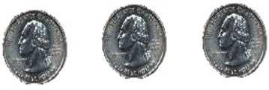

_________________________

121. What is the name of the shape that is created when these two triangles are put together along their long edges?

- Square

- Rectangle
- Circle

32

- What is the temperature shown on the thermometer? Each mark stands for 2 degrees.
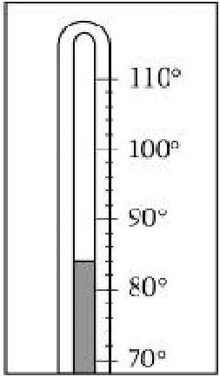

________________degrees

123.

Kelly placed a tile on the table like this: Sara came by and turned the tile

like this: Sara said "It is still a square." Is she right? Explain your answer.

____________________________________________________________________________

124. What is the place value of the underline digit, hundred, ten or one?

26 | __ten__ |  | 20
237 | __________ | _____
487 | __________ | _____
368 | __________ | _____

33

- Find the sum or difference: Remember when subtracting always tell yourself “Bottom bigger better borrow”.

135 | 546 | 71 | 50 | 354 | 63 | 426
+479 | +137 | - 18 | -26 | - 235 | -42 | -135

42 | 54 | 135 | 32 | 88 | 81 | 48
+18 | - 39 | - 53 | - 28 | +13 | - 57 | -26

126. Write the following numbers:

405 _______________________________________________________

732________________________________________________________

Six hundred one ________

Five hundred twenty two _______

Congratulations!! You have completed the summer math packet. Please turn this packet into you third grade teacher.

